The Annual Quality Assurance Report (AQAR) 2012-13 of the IQAC
CHAIDUAR COLLEGE, GOHPUR, SONITPUR, ASSAM
PIN: 784168

All NAAC accredited institutions will submit an annual self-reviewed progress report to NAAC, through its IQAC. The report is to detail the tangible results achieved in key areas, specifically identified by the institutional IQAC at the beginning of the academic year. The AQAR will detail the results of the perspective plan worked out by the IQAC. (Note: The AQAR period would be the Academic Year. For example, July 1, 2012 to June 30, 2013)

Part – A
2012-13
AQAR for the year (for example 2013-14)

1. Details of the Institution
CHAIDUAR COLLEGE
1.1 Name of the Institution
P.O. GOHPUR, DIST. SONITPUR

,,
1.2 Address Line 1

Address Line 2
GOHPUR
City/Town
ASSAM
State
784168
Pin Code
chaiduarcollege@gmail.com
Institution e-mail address
+919435187475, 03715-243158
Contact Nos.
DR. ANJAN KUMAR OZAH
Name of the Head of the Institution:

Tel. No. with STD Code:
03715-243158
+919435187475
Mobile:
SOUMITRA BORUAH
Name of the IQAC Co-ordinator:
+919435183071
Mobile:
iqaccdc@gmail.com
IQAC e-mail address:

1.3 NAAC Track ID (For ex. MHCOGN 18879)
OR

1.4 NAAC Executive Committee No. & Date:
EC/54/RAR/041dated 08/01/2011
(For Example EC/32/A&A/143 dated 3-5-2004.
This EC no. is available in the right corner- bottom
of your institution’s Accreditation Certificate)

www.chaiduarcollege.org
1.5 Website address:
www.chaiduarcollege.org/IQAC/AQAR2012-13.doc

Web-link of the AQAR:
For ex. http://www.ladykeanecollege.edu.in/AQAR2012-13.doc
1.6 Accreditation Details
Sl. No. | Cycle | Grade | CGPA | Year of Accreditation | Validity Period
1 | 1st Cycle | C⁺⁺ | - | 2005 | 5 YEARS
2 | 2nd Cycle | B | 2.64 | 2011 | 5 YARS
3 | 3rd Cycle
4 | 4th Cycle

1.7 Date of Establishment of IQAC : DD/MM/YYYY
17-10-2005

1.8 Details of the previous year’s AQAR submitted to NAAC after the latest Assessment and Accreditation by NAAC ((for example AQAR 2010-11submitted to NAAC on 12-10-2011)
- AQAR _____16/07/2012__________________ _________ (DD/MM/YYYY)
- AQAR______002/07/2015____________ _______________ (DD/MM/YYYY)
- AQAR__________________ _______________________ (DD/MM/YYYY)
- AQAR__________________ _______________________ (DD/MM/YYYY)
1.9 Institutional Status
√√

University State Central Deemed Private
√

Affiliated College Yes No
√√
Constituent College Yes No

Autonomous college of UGC Yes No

√

√
Regulatory Agency approved Institution Yes No
(eg. AICTE, BCI, MCI, PCI, NCI)
√

Type of Institution Co-education Men Women
√

Urban Rural Tribal

√
√
√
Financial Status Grant-in-aid UGC 2(f) UGC 12B

Grant-in-aid + Self Financing Totally Self-financing
√

1.10 Type of Faculty/Programme
√

√

Arts Science Commerce Law PEI (Phys Edu)
√

TEI (Edu) Engineering Health Science Management

Others (Specify)

1.11 Name of the Affiliating University (for the Colleges)
GAUHATI UNIVERSITY

1.12 Special status conferred by Central/ State Government-- UGC/CSIR/DST/DBT/ICMR etc
NO
Autonomy by State/Central Govt. / University
NO
University with Potential for Excellence UGC-CPE
NO
NO
NO
DST Star Scheme UGC-CE
NO
NO
UGC-Special Assistance Programme DST-FIST
YES
NIL
UGC-Innovative PG programmes Any other (Specify)
YES
UGC-COP Programmes
2. IQAC Composition and Activities
10
2.1 No. of Teachers
02
2.2 No. of Administrative/Technical staff
02
2.3 No. of students
2.4 No. of Management representatives
02
02
2.5 No. of Alumni
2. 6 No. of any other stakeholder and
02
community representatives
02
2.7 No. of Employers/ Industrialists
01
2.8 No. of other External Experts
2.9 Total No. of members
23
2.10 No. of IQAC meetings held 02
4
1
2.11 No. of meetings with various stakeholders: No. Faculty
1
1
1
Non-Teaching Staff Students Alumni Others

√

2.12 Has IQAC received any funding from UGC during the year? Yes No
NA
If yes, mention the amount
2.13 Seminars and Conferences (only quality related)
(i) No. of Seminars/Conferences/ Workshops/Symposia organized by the IQAC
0
0
0
0
0
Total Nos. International National State Institution Level
NA
(ii) Themes
2.14 Significant Activities and contributions made by IQAC
Orientation programme for the semistar students
Exit meeting for VI semistar students

2.15 Plan of Action by IQAC/Outcome
The plan of action chalked out by the IQAC in the beginning of the year towards quality
enhancement and the outcome achieved by the end of the year *

Plan of Action | Achievements
Orientation for the semistar students  Institutional workshop on the Grade point system for the students  Career counselling for the VI Semistar Students | Executed  Executed  Executed

* Attach the Academic Calendar of the year as Annexure.

2.15 Whether the AQAR was placed in statutory body Yes No
√

Management Syndicate Any other body
Provide the details of the action taken
Has been approved by Statutory Body

Part – B
Criterion – I

1. Curricular Aspects

1.1 Details about Academic Programmes
Level of the Programme | Number of existing Programmes | Number of programmes added during the year | Number of self-financing programmes | Number of value added / Career Oriented programmes
PhD
PG | 03 | 00 | 00 | 00
UG | 09 | 01 | 01 | 04
PG Diploma
Advanced Diploma
Diploma
Certificate | 01 | 01 | 01 | 00
Others | 02 | 00 | 00 | 00
Total | 15 | 02 | 02 | 04

Interdisciplinary
Innovative | 01 |  | 00 | 00

1.2 (i) Flexibility of the Curriculum: CBCS/Core/Elective option / Open options
(ii) Pattern of programmes:
Pattern | Number of programmes
Semester | 09
Trimester
Annual

√

1.3 Feedback from stakeholders* Alumni Parents Employers Students
(On all aspects)

√

Mode of feedback : Online Manual Co-operating schools (for PEI)
*Please provide an analysis of the feedback in the Annexure

1.4 Whether there is any revision/update of regulation or syllabi, if yes, mention their salient aspects.
NA

1.5 Any new Department/Centre introduced during the year. If yes, give details.
B.Com

Criterion – II
2. Teaching, Learning and Evaluation
2.1 Total No. of permanent faculty
Total | Asst. Professors | Associate Professors | Professors | Others
45 | 32 | 12 | 00 | 00
15
2.2 No. of permanent faculty with Ph.D.
2.3 No. of Faculty Positions Recruited (R) and Vacant (V) during the year
Asst. Professors |  | Associate Professors |  | Professors |  | Others |  | Total
R | V | R | V | R | V | R | V | R | V
01 | 00 | 00 | 00 | 00 | 00 | 00 | 00 | 01 | 00
02
01
01
2.4 No. of Guest and Visiting faculty and Temporary faculty

2.5 Faculty participation in conferences and symposia:

No. of Faculty | International level | National level | State level
Attended Seminars/ Workshops | 02 | 06 | 02
Presented papers | 00 | 06 | 02
Resource Persons | 00 | 00 | 00

2.6 Innovative processes adopted by the institution in Teaching and Learning:
Use of white /digital /smart board and ICT

218

2.7 Total No. of actual teaching days
during this academic year
2.8 Examination/ Evaluation Reforms initiated by
MCQ in sessional exam.
the Institution (for example: Open Book Examination, Bar Coding,
Double Valuation, Photocopy, Online Multiple Choice Questions)

01

2.9 No. of faculty members involved in curriculum
restructuring/revision/syllabus development
as member of Board of Study/Faculty/Curriculum Development workshop
72
2.10 Average percentage of attendance of students

2.11 Course/Programme wise
distribution of pass percentage :

Title of the Programme | Total no. of students appeared | Division
Title of the Programme | Total no. of students appeared | Distinction % | I % | II % | III % | Pass %
SEMISTER I&II | 891 |  |  |  |  | 63
SEM III&IV | 749 |  |  |  |  | 80
SEM V& VI | 571 |  | 53 |  |  | 94

2.12 How does IQAC Contribute/Monitor/Evaluate the Teaching & Learning processes:
1. Introduction of MCQ in sessional & internal assessment examination.
2. Assignment for the 1st semester student and project work for the six semester students.
2.13 Initiatives undertaken towards faculty development
Faculty / Staff Development Programmes | Number of faculty  benefitted
Refresher courses | NA
UGC – Faculty Improvement Programme | NA
HRD programmes | NA
Orientation programmes | NA
Faculty exchange programme | NA
Staff training conducted by the university | NA
Staff training conducted by other institutions | 02 for nonteaching & 01 for teaching
Summer / Winter schools, Workshops, etc. | NA
Others
2.14 Details of Administrative and Technical staff
Category | Number of Permanent  Employees | Number of Vacant  Positions | Number of permanent positions filled during the Year | Number of positions filled temporarily
Administrative Staff | 03 | 01
Technical Staff | 01 | 01
Criterion – III
3. Research, Consultancy and Extension
3.1 Initiatives of the IQAC in Sensitizing/Promoting Research Climate in the institution
IQAC propagates various research grants at UGC, DBT, DST etc.
IQAC plays role in receiving grants from various agencies.

3.2 Details regarding major projects
 | Completed | Ongoing | Sanctioned | Submitted
Number | 02 | 02 |  | 02
Outlay in Rs. Lakhs | 13 | 08 |  | 22

3.3 Details regarding minor projects
 | Completed | Ongoing | Sanctioned | Submitted
Number | 05 | 03 |  | 04
Outlay in Rs. Lakhs | 06 | 04 |  | 06

3.4 Details on research publications
 | International | National | Others
Peer Review Journals | 02 | 04
Non-Peer Review Journals | 01 | 02
e-Journals | 01 | 01
Conference proceedings | 07 | 12

3.5 Details on Impact factor of publications:
3
2

08
Range Average h-index Nos. in SCOPUS
3.6 Research funds sanctioned and received from various funding agencies, industry and other organisations
Nature of the Project | Duration  Year | Name of the  funding Agency | Total grant  sanctioned | Received
Major projects | 03 | UGC/DST | 13 | ALL
Minor Projects | 02 | UGC | 08 | ALL
Interdisciplinary Projects
Industry sponsored
Projects sponsored by the University/ College
Students research projects
(other than compulsory by the University)
Any other(Specify)
Total |  |  | 21 | ALL

3.7 No. of books published i) With ISBN No. Chapters in Edited Books
04
02
02
ii) Without ISBN No.
3.8 No. of University Departments receiving funds from
UGC-SAP CAS DST-FIST

DPE DBT Scheme/funds
3.9 For colleges Autonomy CPE DBT Star Scheme

INSPIRE CE Any Other (specify)

NIL
3.10 Revenue generated through consultancy
Level | International | National | State | University | College
Number |  | 01 | 01 |  | 02
Sponsoring agencies |  | UGC | College |  | College
3.11 No. of conferences
organized by the Institution
01
3.12 No. of faculty served as experts, chairpersons or resource persons
00
01
00
3.13 No. of collaborations International National Any other
01
3.14 No. of linkages created during this year
3.15 Total budget for research for current year in lakhs:
21

From funding agency From Management of University/College
Total
21

3.16 No. of patents received this year
Type of Patent |  | Number
National | Applied | 00
National | Granted | 00
International | Applied | 00
International | Granted | 00
Commercialised | Applied | 00
Commercialised | Granted | 00

3.17 No. of research awards/ recognitions received by faculty and research fellows
Of the institute in the year
Total | International | National | State | University | Dist | College
01 | 00 | 01 | 00 | 00 | 00 | 00

3.18 No. of faculty from the Institution
01
who are Ph. D. Guides
and students registered under them
01

3.19 No. of Ph.D. awarded by faculty from the Institution
00

3.20 No. of Research scholars receiving the Fellowships (Newly enrolled + existing ones)
00
00
JRF SRF Project Fellows Any other
00
00

3.21 No. of students Participated in NSS events:
50
20
University level State level
National level International level
00
00

3.22 No. of students participated in NCC events:
50
20
University level State level
National level International level

3.23 No. of Awards won in NSS:
01
University level State level
00
National level International level
00
00

3.24 No. of Awards won in NCC:
University level State level
00
01
National level International level
00
00

3.25 No. of Extension activities organized
00
02
University forum College forum
01
01
00
NCC NSS Any other

3.26 Major Activities during the year in the sphere of extension activities and Institutional Social Responsibility
- Adoption of village for awareness of all-round development.
- Organizing women health and awareness programme.
- Visiting distant area for awareness of adult education by faculty.

Criterion – IV
4. Infrastructure and Learning Resources
4.1 Details of increase in infrastructure facilities:
Facilities | Existing | Newly created | Source of Fund | Total
Campus area | 29.96 acre | 0 |  | 29.96 acre
Class rooms | 27 | 4 |  | 31
Laboratories | 10 | 0 |  | 10
Seminar Halls | 1 | 1 |  | 2
No. of important equipments purchased (≥ 1-0 lakh) during the current year.
Value of the equipment purchased during the year (Rs. in Lakhs)
Others

4.2 Computerization of administration and library
Administration and Library are computerized. Barcoding in library is yet to be done. Circulation of book is executed using soul software.

4.3 Library services:
 | Existing |  | Newly added |  | Total
 | No. | Value | No. | Value | No. | Value
Text Books | 12320 | - | 755 | - | 13075 | -
Reference Books | 7891 | - | 635 | - | 8526 | -
e-Books | - | - | - | - | -
Journals | 08 | - | 05 | - | 13 | -
e-Journals | - | - | - | - | - | -
Digital Database | 01 | -- | - | - | 01
CD & Video | 10 | - | 08 | - | 18 | -
Others (specify) | 650 | - | 215 | - | 865 | -

4.4 Technology up gradation (overall)
 | Total Computers | Computer Labs | Internet | Browsing Centres | Computer Centres | Office | Depart-ments | Others
Existing | 52 | 01 | 05 | 00 | 01 | 01 | 10 | 01
Added | 02 | 00 | 00 | 00 | 00 | 00 | 00 | 00
Total | 54 | 01 | 05 | 00 | 01 | 01 | 12 | 01

4.5 Computer, Internet access, training to teachers and students and any other programme for technology
upgradation (Networking, e-Governance etc.)
01 for nonteaching staff

4.6 Amount spent on maintenance in lakhs:
1.1
i) ICT
1.52
ii) Campus Infrastructure and facilities

iii) Equipments
2.0
4.0
iv) Others

8.62
Total :

Criterion – V
5. Student Support and Progression
5.1 Contribution of IQAC in enhancing awareness about Student Support Services
1. Conduction of orientation prgramme for first semester students.
2. Exit meeting for six semester students
3. Parent teacher meeting
4. Alumni meeting.

5.2 Efforts made by the institution for tracking the progression
1. Feedback from student
2. Self-appraisal
3. Student councelling
4. Suggestion box

5.3 (a) Total Number of students
UG | PG | Ph. D. | Others
1379 | 00 | 00 | 00

(b) No. of students outside the state
13
00
(c) No. of international students

No | %
00
Men Women
No | %
00
Last Year |  |  |  |  |  | This Year
General | SC | ST | OBC | Physically Challenged | Total | General | SC | ST | OBC | Physically Challenged | Total
331 | 101 | 298 | 405 | 0 | 1135 | 505 | 118 | 288 | 468 | 00 | 1379
Demand ratio 1:2 Dropout % 25(due to admission in different courses)
5.4 Details of student support mechanism for coaching for competitive examinations (If any)
- Training to face Bank Examination
- Pre coaching for Medical and Engineering Entrance

260
No. of students beneficiaries

5.5 No. of students qualified in these examinations
01
01

NET SET/SLET GATE CAT
IAS/IPS etc State PSC UPSC Others

02

5.6 Details of student counselling and career guidance
Career guidance programme on
- Application on digital media
- Financial engagement and management benefit
- Career enhancement programme

210
No. of students benefitted
5.7 Details of campus placement
On campus |  |  | Off Campus
Number of Organizations Visited | Number of Students Participated | Number of Students Placed | Number of Students Placed
NIL | NA | NA | NA

5.8 Details of gender sensitization programmes
- Orientation programme for Girls” students
- Female health checkup camp

5.9 Students Activities

5.9.1 No. of students participated in Sports, Games and other events
08
00
00
State/ University level National level International level

No. of students participated in cultural events
21
00
00
State/ University level National level International level

5.9.2 No. of medals /awards won by students in Sports, Games and other events
00
00
02
Sports : State/ University level National level International level
01
00
00
Cultural: State/ University level National level International level

5.10 Scholarships and Financial Support
 | Number of  students | Amount
Financial support from institution | 20 | 25000
Financial support from government | 625 | 3398330
Financial support from other sources | 02 | 20000
Number of students who received International/ National recognitions | 00 | 00

5.11 Student organised / initiatives
00
00
00
Fairs : State/ University level National level International level
00
00
00
Exhibition: State/ University level National level International level
02
5.12 No. of social initiatives undertaken by the students

5.13 Major grievances of students (if any) redressed: Provision for available drinking water facility.

Criterion – VI
6. Governance, Leadership and Management
6.1 State the Vision and Mission of the institution
The mission of Chaiduar College is to prepare the youth to remain resolutely fixed to their goal and
to obtain insights and awareness over changing values and perspectives of life so as to enable them
to identify themselves as conscious, integrated and wholesome human beings capable of meeting
the challenge and opportunity of life in the noblest and most discipline way.

noblest and most disciplined way.

6.2 Does the Institution has a management Information System
NA

6.3 Quality improvement strategies adopted by the institution for each of the following:
6.3.1 Curriculum Development
NIL

6.3.2 Teaching and Learning
The IQAC is in contact with principal and HOD for all-round development of the institution.

6.3.3 Examination and Evaluation
Conducting sessional examination, project work and assignment to the students and internal assessment of the students.

6.3.4 Research and Development
NA

6.3.5 Library, ICT and physical infrastructure / instrumentation
Library will be put in Bar Code system, enhancement of the reading room under process.

6.3.6 Human Resource Management
All the faculty members are involved with the society

6.3.7 Faculty and Staff recruitment
This is in accordance with the govt. rule. Authority recruits ad-hoc faculty when required.

6.3.8 Industry Interaction / Collaboration
Chemistry Department and Physics Department are in touch with different industries of the locality.

6.3.9 Admission of Students
Students’ admission is made on the merit basis with due reservation for students of SC, ST, OBC.

Teaching | Credit Society
Non teaching | Credit Society
Students | Student aid fund

6.4 Welfare schemes for

5, 70,000
6.5 Total corpus fund generated
√

6.6 Whether annual financial audit has been done Yes No

6.7 Whether Academic and Administrative Audit (AAA) has been done?
Audit Type | External |  | Internal
Audit Type | Yes/No | Agency | Yes/No | Authority
Academic | No | NA | Yes | Yes
Administrative | Yes | State Govt. | Yes | College

6.8 Does the University/ Autonomous College declares results within 30 days? NA
For UG Programmes Yes No

For PG Programmes Yes No
6.9 What efforts are made by the University/ Autonomous College for Examination Reforms?
NA

6.10 What efforts are made by the University to promote autonomy in the affiliated/constituent colleges?
NA

6.11 Activities and support from the Alumni Association
Annual meeting is organised. They are in life touch with the college

6.12 Activities and support from the Parent – Teacher Association
Parent teacher meeting in per semester is organised. Suggestions are in corporate.

6.13 Development programmes for support staff
Holding computer programme for non-teaching staff.

6.14 Initiatives taken by the institution to make the campus eco-friendly
- Process for making a green campus.
- Installation of solar system is in process.
- Availability of pure drinking water facility.

Criterion – VII
7. Innovations and Best Practices
7.1 Innovations introduced during this academic year which have created a positive impact on the
functioning of the institution. Give details.
- Introduction of language lab in the institution.
- Computer training for non-teaching staff.
- Digitization of class room.

7.2 Provide the Action Taken Report (ATR) based on the plan of action decided upon at the
beginning of the year
Yes, as per plan.

7.3 Give two Best Practices of the institution (please see the format in the NAAC Self-study Manuals)
- Counselling
- Taking regular feedback from students

*Provide the details in annexure (annexure need to be numbered as i, ii,iii)
7.4 Contribution to environmental awareness / protection
Process for installing solar system.
Process for making pure drinking water available.
Making the campus green.

√

7.5 Whether environmental audit was conducted? Yes No

7.6 Any other relevant information the institution wishes to add. (For example SWOT Analysis)
SWOT is in Annexure III.
Principal himself and some of the faculty members are the member of screening committee for appointment.

8. Plans of institution for next year
Plan for making existing laboratories up-to-date.
Construction of indoor stadium and development of outdoor play ground.
Building of new class rooms along with seminar and conference hall.

Name Saumitra Kumar Borah Name Dr. Anjan Kumar Ozah.



_______________________________ _______________________________
Signature of the Coordinator, IQAC Signature of the Chairperson, IQAC

_______***_______

Annexure I
Abbreviations:
CAS - Career Advanced Scheme
CAT - Common Admission Test
CBCS - Choice Based Credit System
CE - Centre for Excellence
COP - Career Oriented Programme
CPE - College with Potential for Excellence
DPE - Department with Potential for Excellence
GATE - Graduate Aptitude Test
NET - National Eligibility Test
PEI - Physical Education Institution
SAP - Special Assistance Programme
SF - Self Financing
SLET - State Level Eligibility Test
TEI - Teacher Education Institution
UPE - University with Potential Excellence
UPSC - Union Public Service Commission

***************

ANNEXURE –I
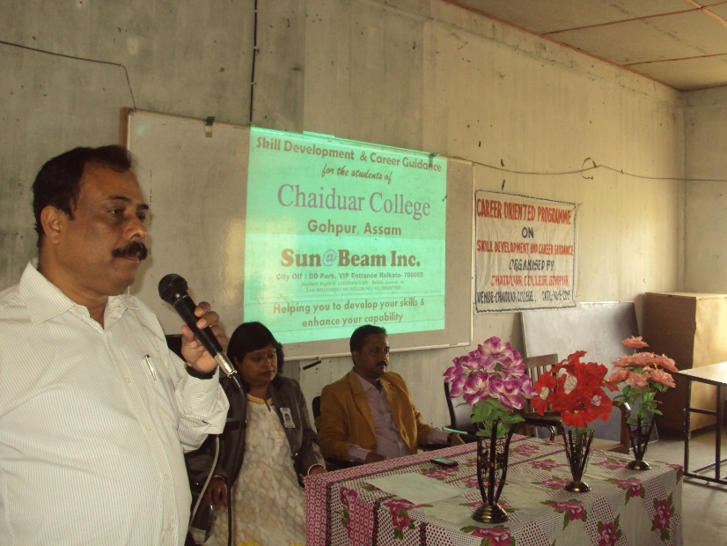
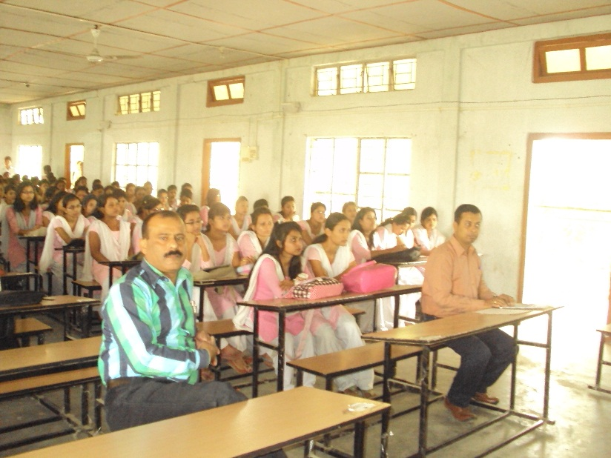
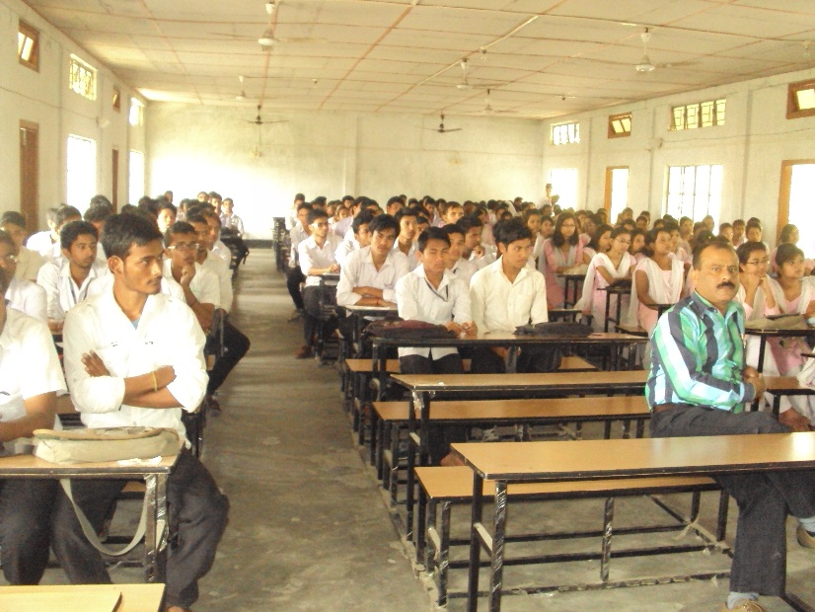

ANNEXURE -II
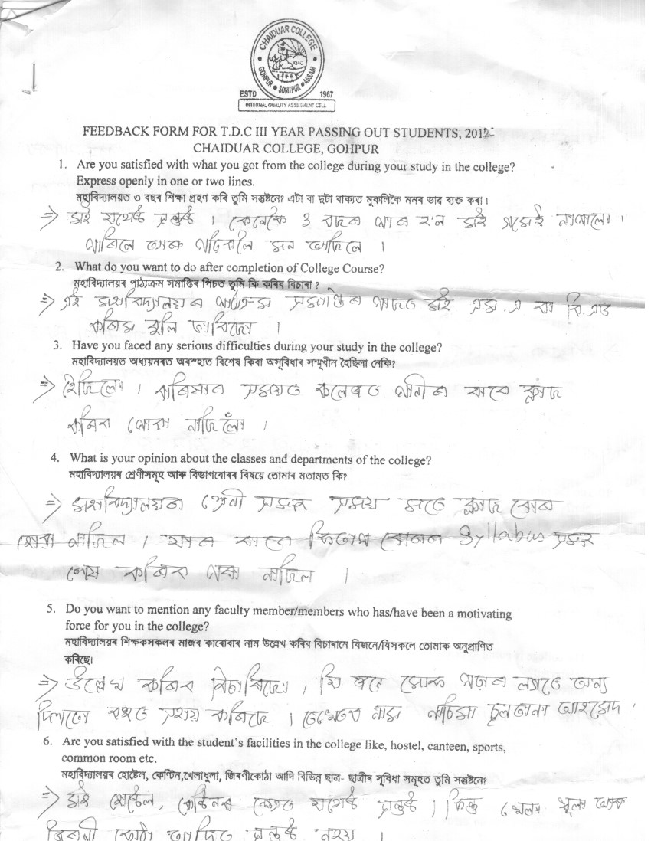

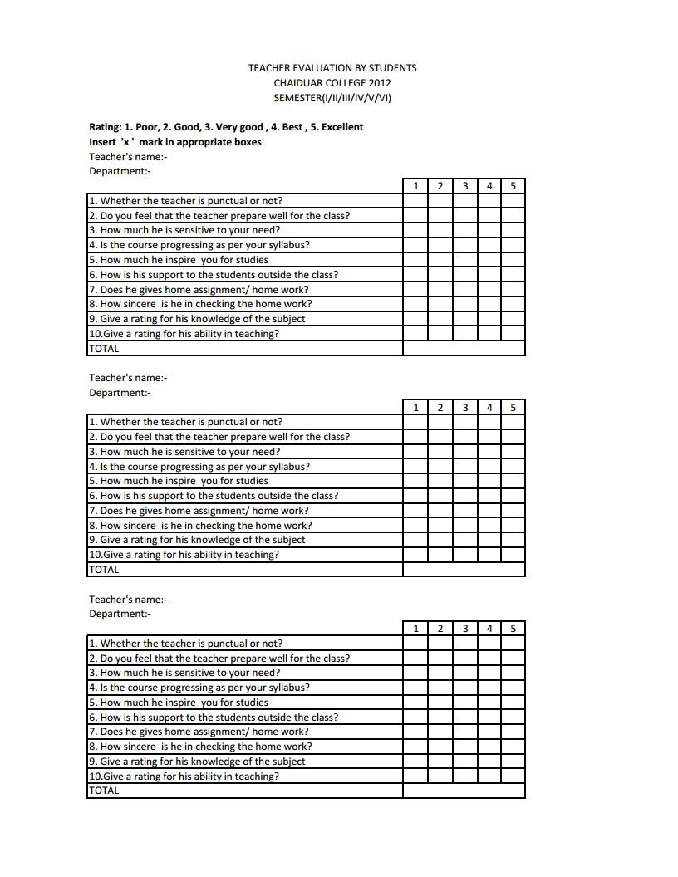
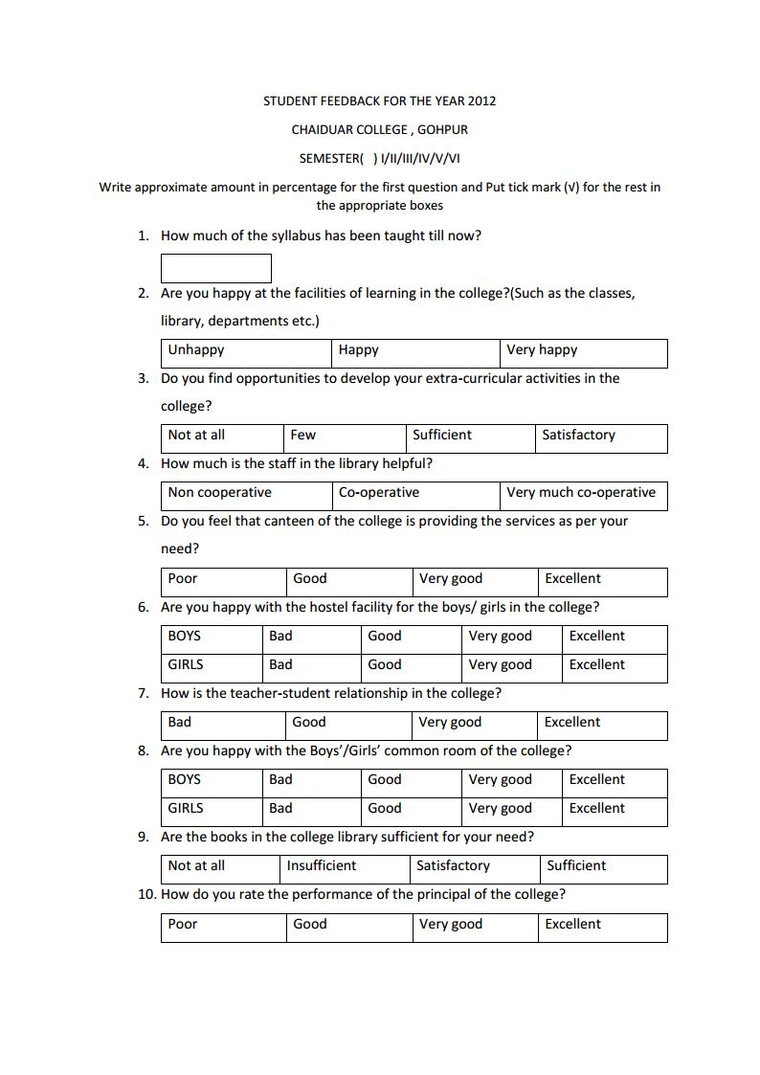
ANNEXURE- III
SWOT ANALYSIS
• Strength: Despite being located in a semi-urban place, Chaiduar College has been imparting quality education effectively and it has provided avenues of opportunities to socially and economically marginalized sections of the society. Set amidst a populace largely dependent on agriculture, the college has commendable placement record which is the result of introduction and effective implementation of career and job oriented Add-on courses. The College is benefitted because of effective leadership with proactive management. A fully equipped computer centre facilitates all the needs of the researchers and students in the college. ICT enabled teaching-learning process is highly encouraged and practiced and adequate facilities are there in the form of smart-class rooms with LCD projectors, online UPS backup and digital classrooms. Almost all the departments have been facilitated with internet connectivity via broadband. The institution has a dynamic website. A fully digitized Central Library caters to the need of the students and teachers alike. The college tries its utmost in maintaining an ambience which promotes equity and gender sensitivity and visible student satisfaction. Scholarships to meritorious but economically poor students are given by financial contributions from the Teachers Unit of the College. A few scholarships are also given from the Bio-Tech Hub of the Department of Zoology. Moreover, special incentives are given to those students who excel in academic performance. Faculty and administrative staff are committed to the goals of the institution and they keep themselves abreast with the latest academic and other relevant spheres of knowledge by way of trainings, workshops, seminars, conferences etc. A vibrant research culture exists in the college. Faculty members are engaged in research activities. Many of them have completed M.Phil and PhD degrees, and they are pursuing research work, Minor/Major Projects. They also attend national/International seminars and conferences and special leave for these and other research activities is allowed. An active Placement Cell facilitates counselling to the students in academic and professional areas. Besides well-ventilated, illuminated lecture rooms and well equipped science laboratories, mention can be made of other facilities such as auditorium, a girls’ hostel, Sports facilities, a canteen within the campus, and a state-of-the-art language lab in the department of English. Another significant strength of the college is the presence of large number of parents and alumni which shows the culture of oneness and participatory relationship with the college. Being situated in an underdeveloped region the college plays a significant role in various forms of support to the following stakeholders through its extension education programs such as awareness programs on environment and AIDS. Social Service Camps are held regularly by the NSS and the NCC. Free medical check-up camps and various outreach programs are undertaken by the college.
• Weakness: The success rate of students in the University Examinations stands at around 75%. Institutionalized bridge course could not yet be introduced for students who have lagged behind in their academic careers. Consultancy and collaboration work are not very strong. Of course, a few collaborative research woks have been done with other universities in the region, and some industry-interface has been initiated. But a lot more needs to be done in this regard. The college has a small boys’ hostel which is not adequate and increase of intake capacity would have benefitted large number of students from far-flung areas. Moreover student-teacher ratio is quite high, especially in the humanities classes which impede effective classroom teaching and management. Number of smart-class room needs to be increased along with further modernization and up gradation of existing laboratories.
• Opportunities: Owing to the inherent strengths as outlined above, the college has the potential to span out further and open new avenues of opportunities in the near future. It may start multi-disciplinary, multi-dimensional courses of relevance such as Dramatics, performing arts, Video-editing, animation, tea-husbandry etc. The institution looks forward to establish more industry-institution, institution-institution interface. There is a wide scope for small-scale research based on student and community participation which may lead to new understanding regarding the ethnic, demographic, cultural, and ecological scenario of this area.
• Threats: As the college is situated in a low lying area, it often faces the problem of flooding during the monsoon season. The flood poses considerable hardships inside the campus. During elections, the college is taken over by the government and it is used as strong-rooms which hampers academic ambience in the college. Another factor that has proven to be an impediment to the academic excellence is the insufficient teaching staff. The student-teacher ratio is very high, and the government has so far given a deaf ear to this urgent need for more teaching posts. The social practice of early marriage among the students often results in drop-outs of girl students. Sometimes, male students leave their studies mid-way and migrate to metropolitan centres in search of jobs. These causes of drop-outs need to be addressed.

