The Annual Quality Assurance Report (AQAR) 2015-16 of the IQAC
CHAIDUAR COLLEGE, GOHPUR, SONITPUR, ASSAM
PIN: 784168

All NAAC accredited institutions will submit an annual self-reviewed progress report to NAAC, through its IQAC. The report is to detail the tangible results achieved in key areas, specifically identified by the institutional IQAC at the beginning of the academic year. The AQAR will detail the results of the perspective plan worked out by the IQAC. (Note: The AQAR period would be the Academic Year. For example, July 1, 2015 to June 30, 2016)

Part – A
2015-16
AQAR for the year (for example 2015-16)

1. Details of the Institution
CHAIDUAR COLLEGE
1.1 Name of the Institution
P.O. GOHPUR, DIST. Biswanath (Formerly SONITPUR)

,,
1.2 Address Line 1

Address Line 2
GOHPUR
City/Town
ASSAM
State
784168
Pin Code
chaiduarcollege@gmail.com
Institution e-mail address
+919435187475, 03715-243158
Contact Nos.
DR. ANJAN KUMAR OZAH
Name of the Head of the Institution:

Tel. No. with STD Code:
03715-243158
+919435187475
Mobile:
SOUMITRA BORUAH
Name of the IQAC Co-ordinator:
+919435183071
Mobile:
iqaccdc@gmail.com
IQAC e-mail address:

ASCOGN11666
1.3 NAAC Track ID (For ex. MHCOGN 18879)
OR

1.4 NAAC Executive Committee No. & Date:
EC/54/RAR/041dated 08/01/2011
(For Example EC/32/A&A/143 dated 3-5-2004.
This EC no. is available in the right corner- bottom
of your institution’s Accreditation Certificate)

www.chaiduarcollege.org
1.5 Website address:
www.chaiduarcollege.org/IQAC/AQAR2015-16.doc

Web-link of the AQAR:
For ex. http://www.ladykeanecollege.edu.in/AQAR2012-13.doc
1.6 Accreditation Details
Sl. No. | Cycle | Grade | CGPA | Year of Accreditation | Validity Period
1 | 1st Cycle | C⁺⁺ | - | 2005 | 5 YEARS
2 | 2nd Cycle | B | 2.64 | 2011 | 5 YARS
3 | 3rd Cycle
4 | 4th Cycle

1.7 Date of Establishment of IQAC: DD/MM/YYYY
17-10-2005

1.8 Details of the previous year’s AQAR submitted to NAAC after the latest Assessment and Accreditation by NAAC ((for example AQAR 2010-11submitted to NAAC on 12-10-2011)
- AQAR _____16/07/2012__________________ _________ (DD/MM/YYYY)
- AQAR______02/07/2015____________ _______________ (DD/MM/YYYY)
- AQAR____03/11/2015_____________ _______________ (DD/MM/YYYY)
- AQAR_____07/01/2016____ _______________________ (DD/MM/YYYY)
- AQAR_____25/02/2017____ _______________________ (DD/MM/YYYY)
1.9 Institutional Status
√√

University State Central Deemed Private
√

Affiliated College Yes No
√√
Constituent College Yes No

Autonomous college of UGC Yes No

√

√
Regulatory Agency approved Institution Yes No
(eg. AICTE, BCI, MCI, PCI, NCI)
√

Type of Institution Co-education Men Women
√

Urban Rural Tribal

√
√
√
Financial Status Grant-in-aid UGC 2(f) UGC 12B
√
Grant-in-aid + Self Financing Totally Self-financing

1.10 Type of Faculty/Programme
√

√

Arts Science Commerce Law PEI (Phys Edu)
√

TEI (Edu) Engineering Health Science Management

B.Voc and Community College
Others (Specify)
GAUHATI UNIVERSITY
1.11 Name of the Affiliating University (for the Colleges)

1.12 Special status conferred by Central/ State Government-- UGC/CSIR/DST/DBT/ICMR etc
NO
Autonomy by State/Central Govt. / University
NO
University with Potential for Excellence UGC-CPE
NO
NO
NO
DST Star Scheme UGC-CE
NO
NO
UGC-Special Assistance Programme DST-FIST
YES
DBT Star College
UGC-Innovative PG programmes Any other (Specify)
YES
UGC-COP Programmes
2. IQAC Composition and Activities
10
2.1 No. of Teachers
02
2.2 No. of Administrative/Technical staff
02
2.3 No. of students
2.4 No. of Management representatives
02
02
2.5 No. of Alumni
2. 6 No. of any other stakeholder and
02
community representatives
02
2.7 No. of Employers/ Industrialists
01
2.8 No. of other External Experts
2.9 Total No. of members
23
2.10 No. of IQAC meetings held
04
7
3
2.11 No. of meetings with various stakeholders: No. Faculty
2
2
1
Non-Teaching Staff Students Alumni Others

√
2.12 Has IQAC received any funding from UGC during the year? Yes No

If yes, mention the amount
2.13 Seminars and Conferences (only quality related)
(i) No. of Seminars/Conferences/ Workshops/Symposia organized by the IQAC
0
0
0
0
0
Total Nos. International National State Institution Level
NA
(ii) Themes
2.14 Significant Activities and contributions made by IQAC
The college authority in cooperation with the IQAC are instrumental in preparing and submitting the plan proposals to various funding agencies relating to the development grant, building grant, research grant etc. All the major and minor projects to various funding agencies have scrutinized by research cell of IQAC.
By virtue of being a member of every subcommittee formed by the authority the coordinator of IQAC has been providing necessary assistants for the speedy upliftment of the college. The IQAC has prepared a comprehensive prospectus of the college which suffices the query of the aspiring students about the college.

2.15 Plan of Action by IQAC/Outcome
The plan of action chalked out by the IQAC in the beginning of the year towards quality
enhancement and the outcome achieved by the end of the year *

Plan of Action | Achievements
1.Plan for a mock visit by some of the peer team members of neighbour Universities.  2.Different carrier counselling for academic development programme for the students  3. Proposal for running a PG Entrepreneurship development programme for the students. | Proposal has been submitted to authority for concern permission and grant  Executed  Executed

* Attach the Academic Calendar of the year as Annexure.

2.15 Whether the AQAR was placed in statutory body Yes No
√

Management Syndicate Any other body
Provide the details of the action taken
The governing body expressed its satisfaction over the prepared AQAR and directed to forward the report NAAC. It has further taken up some follow up action for necessary enhancement measure for the college.

Part – B
Criterion – I

1. Curricular Aspects

1.1 Details about Academic Programmes
Level of the Programme | Number of existing Programmes | Number of programmes added during the year | Number of self-financing programmes | Number of value added / Career Oriented programmes
PhD
PG | 03(Distance Mode) | 01 | 00 | 00
UG | 10 | 00 | 01 | 04
PG Diploma | 01
Advanced Diploma
Diploma
Certificate | 02 |  | 01 | 00
Others | 02 | 00 | 00 | 00
Total | 18 | 01 | 02 | 04

Interdisciplinary
Innovative | 00 |  | 00 | 00

1.2 (i) Flexibility of the Curriculum: CBCS/Core/Elective option / Open options

(ii) Pattern of programmes:

Pattern | Number of programmes
Semester | 04
Trimester
Annual | 01

√

√

1.3 Feedback from stakeholders* Alumni Parents Employers Students
(On all aspects)

√

Mode of feedback : Online Manual Co-operating schools (for PEI)
*Please provide an analysis of the feedback in the Annexure

1.4 Whether there is any revision/update of regulation or syllabi, if yes, mention their salient aspects.
NA

1.5 Any new Department/Centre introduced during the year. If yes, give details.
NIL

Criterion – II
2. Teaching, Learning and Evaluation
2.1 Total No. of permanent faculty
Total | Asst. Professors | Associate Professors | Professors | Others
41 | 12 | 29 | 00 | 00
20
2.2 No. of permanent faculty with Ph.D.
2.3 No. of Faculty Positions Recruited (R) and Vacant (V) during the year
Asst. Professors |  | Associate Professors |  | Professors |  | Others |  | Total
R | V | R | V | R | V | R | V | R | V
01 | 02 | 00 | 00 | 00 | 00 | 00 | 00 | 00 | 02
02
01
22
2.4 No. of Guest and Visiting faculty and Temporary faculty

2.5 Faculty participation in conferences and symposia:

No. of Faculty | International level | National level | State level
Attended Seminars/ Workshops | 00 | 04 | 02
Presented papers | 00 | 04 | 02
Resource Persons | 00 | 00 | 00

2.6 Innovative processes adopted by the institution in Teaching and Learning:
Cooperative learning, project base learning outdoor learning nonacademic life skill curriculum etc.

184

2.7 Total No. of actual teaching days
during this academic year
2.8 Examination/ Evaluation Reforms initiated by
Nil
the Institution (for example: Open Book Examination, Bar Coding,
Double Valuation, Photocopy, Online Multiple Choice Questions)

02

2.9 No. of faculty members involved in curriculum
restructuring/revision/syllabus development
as member of Board of Study/Faculty/Curriculum Development workshop
73
2.10 Average percentage of attendance of students

2.11 Course/Programme wise
distribution of pass percentage:

Title of the Programme | Total no. of students appeared | Division
Title of the Programme | Total no. of students appeared | Distinction % | I % | II % | III % | Pass %
SEMISTER I&II | 644 |  |  |  |  | 67
SEM III&IV | 580 |  |  |  |  | 80
SEM V& VI | 408 |  | 30.7 |  |  | 75

2.12 How does IQAC Contribute/Monitor/Evaluate the Teaching & Learning processes:
IQAC collects feedback from students and self-appraisal report from teachers. In addition, the necessary steps needed are discussed in open forum.
2.13 Initiatives undertaken towards faculty development
Faculty / Staff Development Programmes | Number of faculty  benefitted
Refresher courses | NA
UGC – Faculty Improvement Programme | NA
HRD programmes | NA
Orientation programmes | NA
Faculty exchange programme | 3
Staff training conducted by the university | NA
Staff training conducted by other institutions | NA
Summer / Winter schools, Workshops, etc. | NA
Others
2.14 Details of Administrative and Technical staff
Category | Number of Permanent  Employees | Number of Vacant  Positions | Number of permanent positions filled during the Year | Number of positions filled temporarily
Administrative Staff | 03 | 01
Technical Staff | 01 | 01
Criterion – III
3. Research, Consultancy and Extension
3.1 Initiatives of the IQAC in Sensitizing/Promoting Research Climate in the institution
A research cell under IQAC has been working in promoting research climate and all major and minor research projects have to be routed through this cell. IOAC meets the principal investigator and fellow of the project running various project to acquaint with difficulties face by them and tries to find out a means by amicable discussion with the authority. IQAC has initiated in publishing a national research journal “Scholar’s View” with ISBN.

3.2 Details regarding major projects
 | Completed | Ongoing | Sanctioned | Submitted
Number | 00 | 00 |  | 00
Outlay in Rs. Lakhs | 00 | 00 |  | 00

3.3 Details regarding minor projects
 | Completed | Ongoing | Sanctioned | Submitted
Number | 00 | 00 | 00 | 00
Outlay in Rs. Lakhs | 00 | 00 | 00 | 00

3.4 Details on research publications
 | International | National | Others
Peer Review Journals | 00 | 04
Non-Peer Review Journals | 01 | 02
e-Journals | 01 | 02
Conference proceedings | 04 | 13

3.5 Details on Impact factor of publications:
3
2

04
Range Average h-index Nos. in SCOPUS
3.6 Research funds sanctioned and received from various funding agencies, industry and other organisations
Nature of the Project | Duration  Year | Name of the  funding Agency | Total grant  sanctioned | Received
Major projects | 00 | NA | 00 | NA
Minor Projects | 00 | NA | 00 | NA
Interdisciplinary Projects
Industry sponsored
Projects sponsored by the University/ College
Students research projects
(other than compulsory by the University)
Any other(Specify)
Total

3.7 No. of books published i) With ISBN No. Chapters in Edited Books
03
02
02
ii) Without ISBN No.

3.8 No. of University Departments receiving funds from: NA
UGC-SAP CAS DST-FIST

DPE DBT Scheme/funds
3.9 For colleges Autonomy CPE DBT Star Scheme

25 Lakhs
INSPIRE CE Any Other (specify)

NIL
3.10 Revenue generated through consultancy

3.11 No. of conferences organized by the Institution

Level | International | National | State | University | College
Number | NIL | NIL | NIL | NIL | 01
Sponsoring agencies

3.12 No. of faculty served as experts, chairpersons or resource persons
01
00
03
00
3.13 No. of collaborations International National Any other
01
3.14 No. of linkages created during this year
3.15 Total budget for research for current year in lakhs:
25

From funding agency From Management of University/College
Total
25

3.16 No. of patents received this year
Type of Patent |  | Number
National | Applied | 00
National | Granted | 00
International | Applied | 00
International | Granted | 00
Commercialised | Applied | 00
Commercialised | Granted | 00

3.17 No. of research awards/ recognitions received by faculty and research fellows
Of the institute in the year
Total | International | National | State | University | Dist | College
00 | 00 | 00 | 00 | 00 | 00 | 00

3.18 No. of faculty from the Institution
02
who are Ph. D. Guides
and students registered under them
03

3.19 No. of Ph.D. awarded by faculty from the Institution
00

3.20 No. of Research scholars receiving the Fellowships (Newly enrolled + existing ones)
00
00
JRF SRF Project Fellows Any other
00
00

3.21 No. of students Participated in NSS events:
University level State level
45
20
National level International level
00
00

3.22 No. of students participated in NCC events: University level State level
25
30

National level International level

3.23 No. of Awards won in NSS:
01
University level State level
00
National level International level
00
00

3.24 No. of Awards won in NCC:
University level State level
00
01
National level International level
00
00

3.25 No. of Extension activities organized
00
02
University forum College forum
01
02
00
NCC NSS Any other
3.26 Major Activities during the year in the sphere of extension activities and Institutional Social Responsibility
- NSS special camp from 20.07.2013 to 29.07.2013
- Regular activities camp on 15th March 2014 in the adopted village.
- Activities at the adopted village for all round development
Criterion – IV
4. Infrastructure and Learning Resources
4.1 Details of increase in infrastructure facilities:
Facilities | Existing | Newly created | Source of Fund | Total
Campus area | 29.96 acre | 0 |  | 29.96 acre
Class rooms | 31 | 4 | UGC | 35
Laboratories | 10 | 0 |  | 10
Seminar Halls | 2 | 1 | UGC | 3
No. of important equipments purchased (≥ 1-0 lakh) during the current year.
Value of the equipment purchased during the year (Rs. in Lakhs) | 50 |  | DBT | 50
Others

4.2 Computerization of administration and library
Administration and Library are computerized. Barcoding is almost completed in the library. Digitalization of library is proposed to be implemented in near future.

4.3 Library services:
 | Existing |  | Newly added |  | Total
 | No. | Value | No. | Value | No. | Value
Text Books | 13967 | - | 550 | - | 14517 | -
Reference Books | 8994 | - | 312 | - | 9304 | -
e-Books | - | - | - | - | -
Journals | 28 | - | 1 | - | 29 | -
e-Journals | 12 | - | - | - | 12 | -
Digital Database | 02 | -- | - | - | 02
CD & Video | 10 | - | 20 | - | 30 | -
Others (specify) | 1059 | - | 117 | - | 1176 | -

4.4 Technology up gradation (overall)
 | Total Computers | Computer Labs | Internet | Browsing Centres | Computer Centres | Office | Depart-ments | Others
Existing | 63 | 01 | 05 | 02 | 01 | 01 | 14 | 01
Added | 11 | 00 | 03 | 00 | 00 | 00 | 00 | 00
Total | 74 | 01 | 08 | 02 | 01 | 01 | 14 | 01

4.5 Computer, Internet access, training to teachers and students and any other programme for technology
upgradation (Networking, e-Governance etc.)

Process for making the college campus Wi-Fi enable is almost completed; the hardware has already been installed. The available facility in the campus will help the management and teachers for various purposes.

4.6 Amount spent on maintenance in lakhs:
4
i) ICT
6.7
ii) Campus Infrastructure and facilities

iii) Equipment
5.0
4.3
iv) Others

20.00
Total :

Criterion – V
5. Student Support and Progression
5.1 Contribution of IQAC in enhancing awareness about Student Support Services
IQAC collects feedback from students on various support services available in the college for enhancement of quality of such support services in the college. The college issues updated prospectus with the help of IQAC which covers material information regarding student support services which students must know before entering into the college. The college has been providing effecting remedial and tutorial services to the students by going through the feedback of the student taken by IQAC.

5.2 Efforts made by the institution for tracking the progression
The college has an academic council comprising of principal, vice principal, coordinator IQAC and the HODs. They meet once in three months to monitor the progress of the individual.

5.3 (a) Total Number of students
UG | PG | Ph. D. | Others
1578 | 00 | 00 | 00

(b) No. of students outside the state
13
00
(c) No. of international students

No | %
909 | 57.6
Men Women
No | %
669 | 42.4
Last Year |  |  |  |  |  | This Year
General | SC | ST | OBC | Physically Challenged | Total | General | SC | ST | OBC | Physically Challenged | Total
630 | 168 | 455 | 705 | 0 | 1958 | 333 | 155 | 443 | 646 | 01 | 1578
Demand ratio 1:2 Dropout % 21(due to admission in different courses)
5.4 Details of student support mechanism for coaching for competitive examinations (If any)
Coaching for entry in service is conducted. Some of the toppers and various successors are invited to address the students. Various reputed coaching institution has been invited to be interacted with the students.

385
No. of student’s beneficiaries

5.5 No. of students qualified in these examinations
02
00

NET SET/SLET GATE CAT
IAS/IPS etc State PSC UPSC Others

00

5.6 Details of student counselling and career guidance
- A separate student counselling center with a counsellor is available in our college.
- The carrier guidance cell headed by a teacher coordinator used to interact with the student for their future benefit.

219
No. of students benefitted
5.7 Details of campus placement
On campus |  |  | Off Campus
Number of Organizations Visited | Number of Students Participated | Number of Students Placed | Number of Students Placed
NIL | NA | NA | NA
5.8 Details of gender sensitization programmes
- Orientation programme for Girls” students
- Female health checkup camps and gender sensitization programmes are conducted regularly by woman cell of the college

5.9 Students Activities

5.9.1 No. of students participated in Sports, Games and other events
07
01
00
State/ University level National level International level

No. of students participated in cultural events
25
00
00
State/ University level National level International level

5.9.2 No. of medals /awards won by students in Sports, Games and other events
02
00
03
Sports: State/ University level National level International level
03
00
00
Cultural: State/ University level National level International level

5.10 Scholarships and Financial Support
 | Number of  students | Amount
Financial support from institution | 30 | 40,000
Financial support from government | 40 | 6,67,225
Financial support from other sources | 02 | 20000
Number of students who received International/ National recognitions | 00 | 00

5.11 Student organised / initiatives
02
00
00
Fairs: State/ University level National level International level
Exhibition: State/ University level National level International level
00
00
00
05
5.12 No. of social initiatives undertaken by the students

5.13 Major grievances of students (if any) redressed: Provision for available drinking water facility.
Grievance: To provide the indoor sports facility for the students within the college campus
Redressed: The construction of the well-equipped indoor stadium is on verge of completion

Criterion – VI
6. Governance, Leadership and Management
6.1 State the Vision and Mission of the institution
The mission of Chaiduar College is to prepare the youth to remain resolutely fixed to their goal and
to obtain insights and awareness over changing values and perspectives of life so as to enable them
to identify themselves as conscious, integrated and wholesome human beings capable of meeting
the challenge and opportunity of life in the noblest and most discipline way.

noblest and most disciplined way.

6.2 Does the Institution has a management Information System
No

6.3 Quality improvement strategies adopted by the institution for each of the following:
6.3.1 Curriculum Development
As we are affiliated to Gauhati University so we cannot directly involve in Curriculum Development. Yet some of our teacher and also the principal on the capacity of their membership of EC of university suggest in this regard.

6.3.2 Teaching and Learning
The college has given due emphasis in providing all necessary teaching aides urged by the departments to make teaching and learning more effective. Assignment of project to students, compulsory seminars by students and exposer visits are in practice.

6.3.3 Examination and Evaluation
The college authority has taken initiatives to improve the quality of the institution by organising internal sessional examinations besides the unit tests. The evaluation reports and also examined answer scripts are displayed for specified period of time. The weaknesses of the students are discussed. Moreover, the science students have to undergo internal practical exam.

6.3.4 Research and Development
The college has a research cell and most of the teachers are engaged in research activities like MRP, PhD and Post-Doctoral Work. A research journal is published regularly twice in a year.

6.3.5 Library, ICT and physical infrastructure / instrumentation
Library software SOLE 2.0 is being used for dispersing books. The bar coding of library is in process. We have well internet facility provided by NMEICT. Digitalization of the library is on the verge of completion.

6.3.6 Human Resource Management
The college has a well scheduled plan to communicate effectively with the staff. The plan encompasses the consultations and negotiations on the key issues of the society with college family. It helps to provide healthy staff relation.

6.3.7 Faculty and Staff recruitment
This is in accordance with the govt. rule. Authority recruits ad-hoc faculty when required.

6.3.8 Industry Interaction / Collaboration
The college invites employer from local industries and arranges for their interaction with students. Students are sent to various industries and laboratories under the guidance of teacher. Hands on training on various fields are arranged under the supervision of concern experts. Over the years, a number of MoUs and collaborations has been signed and established with various industries, medical and entertainement institutions, higher education institutes and research centers.

6.3.9 Admission of Students
Students’ admission is made on the merit basis with due reservation for students of SC, ST, OBC.

6.4 Welfare schemes for
Teaching | Credit Society
Non teaching | Credit Society
Students | Student aid fund

Rs 1000000/-
6.5 Total corpus fund generated
√

6.6 Whether annual financial audit has been done Yes No

6.7 Whether Academic and Administrative Audit (AAA) has been done?
Audit Type | External |  | Internal
Audit Type | Yes/No | Agency | Yes/No | Authority
Academic | No | NA | Yes | Yes
Administrative | Yes | State Govt. | Yes | College

6.8 Does the University/ Autonomous College declares results within 30 days? NA
For UG Programmes Yes No

For PG Programmes Yes No
6.9 What efforts are made by the University/ Autonomous College for Examination Reforms?
NA

6.10 What efforts are made by the University to promote autonomy in the affiliated/constituent colleges?
NA

6.11 Activities and support from the Alumni Association
Alumni association of the college has been actively associated in supporting college authority in many areas. Alumni inside the state, outside the state and also from abroad used to interact with our student when they come to the college. Alumni helps the students in career counselling, higher studies in abroad.

6.12 Activities and support from the Parent – Teacher Association
Parent teacher meeting in per semester is organised. Suggestions are incorporate. Progression and attendance of the students are sent through SMS. Telephonic conversation with parents are in practise.

6.13 Development programmes for support staff
Holding computer programmes for non-teaching staff. New software for office management is installed. Office employees are sent to IT training.

6.14 Initiatives taken by the institution to make the campus eco-friendly
Greening the college campus with various medicinal is in practice. Beautification of college ponds are executed. Pisciculture programme are accorded with college ponds. Organic farming of paddy on the college land is proposed to be started. Annual environment day is observed. Plantation drives and environmental awareness programmes are held. Solid and e-waste are effectively managed and disposed.

Criterion – VII
7. Innovations and Best Practices
7.1 Innovations introduced during this academic year which have created a positive impact on the
functioning of the institution. Give details.
Remedial class for poor and weak student are regularly arranged. Counselling for job opportunity and higher study are done regularly. Woman cell of the college play an active role against sexual harassment and ragging. Academic meeting is held once prior to the beginning of even and odd semester. On the overall thrust where the college has to give emphasis on priority basis. It helps in smooth conduction of the college.

7.2 Provide the Action Taken Report (ATR) based on the plan of action decided upon at the
beginning of the year
GB and IQAC sit together once in a year to discuss the overall progress of the college. Invited speech, popular talk, local seminar on current topic are arranged. Counselling of the students by carrier guidance cell is a regular practice of the college.

7.3 Give two Best Practices of the institution (please see the format in the NAAC Self-study Manuals)
- Counselling for higher education and job opportunity
- Taking regular feedback from students
- Special classes by invitee lectures from nearby college.
- Special coaching for recruitment in service

*Provide the details in annexure (annexure need to be numbered as i, ii,iii)

7.4 Contribution to environmental awareness / protection
- Environment awareness programme at the outside of the college.
- MoU with Public Health Department for available pure drinking water.
- Proposal for greening the campus with medicinal plant.
- Observation of world environment day and Swacch Bharat Abhiyaan

√

7.5 Whether environmental audit was conducted? Yes No

7.6 Any other relevant information the institution wishes to add. (For example SWOT Analysis)
SWOT is in Annexure III.
Principal himself and some of the faculty members are the member of screening committee for appointment.

8. Plans of institution for next year
- More job oriented programmes are to be initiated
- Post Graduate classes are to be started in selected departments (provided permission is accorded by the parent university)
- Sporting facilities are to be further enhanced
- New buildings and laboratories are to be constructed

Name Saumitra Kumar Borah Name Dr. Anjan Kumar Ozah.



_______________________________ _______________________________
Signature of the Coordinator, IQAC Signature of the Chairperson, IQAC

_______***_______

Annexure I
Abbreviations:
CAS - Career Advanced Scheme
CAT - Common Admission Test
CBCS - Choice Based Credit System
CE - Centre for Excellence
COP - Career Oriented Programme
CPE - College with Potential for Excellence
DPE - Department with Potential for Excellence
GATE - Graduate Aptitude Test
NET - National Eligibility Test
PEI - Physical Education Institution
SAP - Special Assistance Programme
SF - Self Financing
SLET - State Level Eligibility Test
TEI - Teacher Education Institution
UPE - University with Potential Excellence
UPSC - Union Public Service Commission

***************

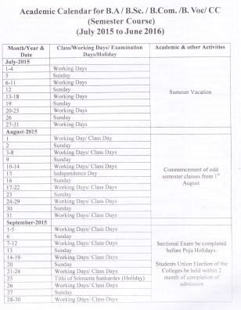

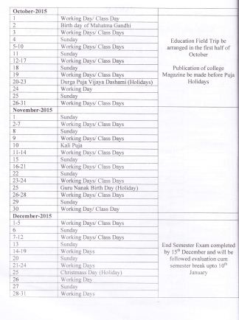

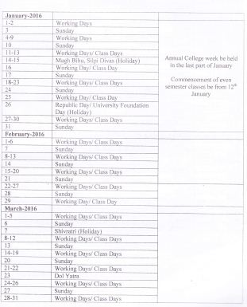

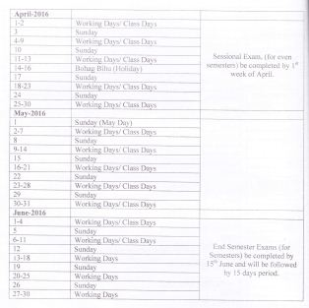
ANNEXURE -II

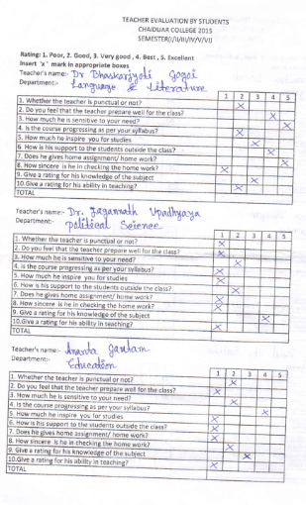

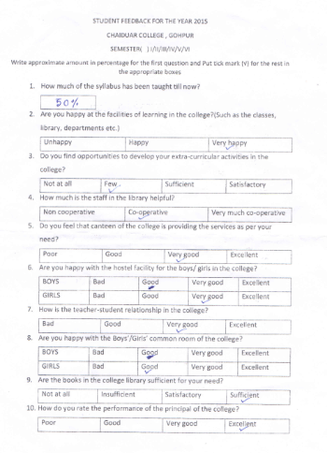

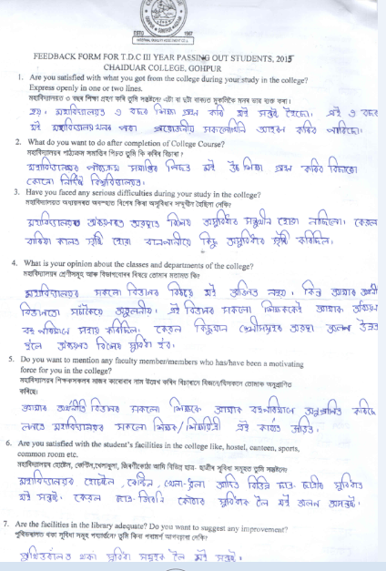

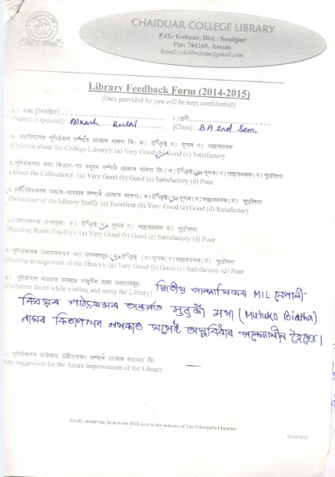

ANNEXURE- III
SWOT ANALYSIS
The college constitutes a major space meant for higher learning in the Gohpur Sub-Division, catering to the need and aspiration of the student community. Rural as the socio economic background and is, the institution wages relentless effort at realizing all-round development of the budding aspirants. Affiliated to the Gauhati University, the college provides education in multiple disciplines, and has carved a niche for itself in the educational map of the region. As the institution has its strengths, it is not away from weakness. With the noble vision, it makes advancement on the basis of strengths, but addressing the weakness within an effective and constructive framework.
Strengths: Since its inception in 1967, this pioneer Institution of higher education has slowly, but firmly gathered intellectual momentum under the dynamic leadership of different stakeholders of education in the college and of the region. It has now emerged as real hub of academic importance accommodating to the regional needs. The region is a place of conglomeration of people of diverse creeds and communities involving the Bodos, Misings, Tea-garden Communities, Assamese, Bengalis, Nepalese, and others. With such a cosmopolitan backdrop, the college has tried its best to deliver quality education to the student community. In recent years, there has been a constant effort to improvise infrastructure, course designs and teaching-learning conditions. As a result of this, the college has been able to access funds from different agencies such as the Department of Science and Technology, Department of Bio Technology, UGC, ICHR etc. Moreover, there has been a consistent rise in research oriented activities in the college. The prominent areas of the strengths of the college are:
- Strongly motivated teaching community, that has demonstrated unprecedented zeal, enthusiasm and efficiency towards the teaching-learning enterprise by incorporating new and effective means of classroom teaching as well as by keeping themselves updated with regard to their domain of knowledge, and engaging themselves in research activities. Justifying this, the college possesses a large numbers faculties having Ph.D.
- A great number of minor and major research projects have been allotted to the teacher community of this institution.
- A Biotech Hub has been established in the college funded by the Department of Bio-Technology, Govt. of India.
- A good number of new generation courses like Medical Laboratory Technician, Mass Media, Health Care and Nursing, Theatre Stage Craft and Acting, Diploma in Entrepreneurship etc., have been introduced, and are running successfully.
- The college also runs parallel courses under open universities namely K.K. Handiqui State Open University, IGNOU and Institute of Distance and Open Learning, Gauhati University. A large number of students enroll in both Under Graduate and Post Graduate level courses in different streams of Arts, Science and Commerce through the study centres of these open universities.
- The library of the college is well-equipped with a rich and constantly growing collection of books and journals. The digitization of the library has been accomplished in due course of time. The library users are increasing every year, and the library has proved to be a hub of resources for faculty members, researchers and students. Besides the central library, each department is equipped with their own departmental libraries.
- There has been a continuous effort at converting traditional lecture halls to smart class room.
- In addition to the laboratories in the department of Physics, Chemistry, Botany, MLT, Zoology and Education (in the arts faculty), the English Department has a well equipped Language Laboratory that imparts skill in Spoken English.
- A grand indoor stadium has been built in the college campus with the funding of Rs. 70 lacs by UGC.
- The college has girls’ hostel which can accommodate 92 girls hailing from fur flung areas.
- A large number of students enroll in NCC and successfully complete the training. The scheme has helped a lot of students in finding jobs in defence and other allied services.
- The college frequently hosts different national level seminars and workshops of academic and cultural importance. Prominent alumni of National School of Drama have participated in providing orientation and training to participants.
- The student and teacher community of the college, showcasing their concerted effort, demonstrate vibrant urge to undertake different extension activities and campaigns like cleanliness drive, holding health camps etc. for the betterment of socio-cultural health and hygiene in the society.
- The college has to its credit different scholarship and merit award schemes, which are annually offered to many poor, but meritorious students.
- A few of the students have demonstrated their interest and skills in games and sports, and they have made the college proud by participating and winning silver medal in international events. Frequently, volley ball and football workshops are instituted, and competitions are held that provide good training for budding players.
- The college has an approximately 5 Hectares land resource which is used for paddy cultivation.
- Not the least, the college has produced a lot of prominent persons who have demonstrated their leadership roles in academic, administrative and social arena. Frequent co-operation with such alumni provide glamour and glory to the great tradition of the college. These are the few of the prominent points of relative strengths that the college has availed during its journey in the quest for excellence in knowledge.
Weaknesses: There are weaknesses too which, of course, can be ameliorated by the concerted effort of different stakeholders of education within and outside the college, the govt. and funding agencies of the major weaknesses mention can be made of
- Fund crunch, needless to say, is the major bottleneck that hinders and delays the good thing to happen in the ground.
- Desperately poor teacher student ratio particularly in Arts stream is another problem faced by the College. A teacher has to teach more than 400 students in a few of the classes. This is terribly poor situation.
- The dominance of traditional liberal Arts subjects motivates lesser number of students. As most of the students come from the poor Socio-economic background,they are in need of getting early employment; in this case, subjects of traditional interest motivate only a limited number of students to excel in their learning.
- As the college is surrounded by small streams coming down from the adjacent Hills of Arunachal Pradesh, most of the times, it remains inundated and the normal routines of the College are disrupted frequently.
Such weaknesses as mentioned, although restrain the required pace of progress, do not necessarily halt the journey, and we strongly believe that appropriate, well-planned and relevant steps, if taken in time, can put the necessary momentum to the journey of the college.
Opportunities: The past experiences, the surrounding socio-economic and cultural perspectives of the College, the critical elaboration of the changes taking place in the society and the nation at large and rapidly transforming socio-cultural, moral and ethical outlook of the student, teacher and the community help us realize the hindsight in identifying the opportunities that the college may access to. These can be as such:
- The great pool of sport talent seems to be abundant among the SC and ST Communities like the Bodo, Mising and Tea garden tribes. Proper training, workshops and instituting competitions can certainly boost their talents to grow.
- By applying appropriate technology, the land resources can be exploited for generation of income.
- The new generation of courses like M.L.T., Mass Media, diploma in Entrepreneurship etc if carried out properly, can open new opportunities for self-employment and enterprise. Such courses have the tremendous potential to change the socio-economic face of the society.
- Further introduction of self-financing courses can attract a few number of students who can bring material changes in their post academic career and thus help the College to be a path finder.
- Encouraging the optional use of man and material resources of the College can be a harbinger for the quest of quality education. The teaching and administrative staff of the College with their dynamic leadership roles can exploit the available resources at their best and thus can transform the ‘alma mater’ to a real ground of formation of human capital.
- The Biotech Hub, the Science Laboratories, the MLT lab and Language Labs are relatively of the better types of assets that can make a real difference in educational sector.
- As an oldest institution for higher education in the region, it can give itself a competitive edge for assuaging the intellectual and academic need of the student community.
- Optimum use of infrastructure.
Threats: The threats are the concomitant elements of every system and institution. These are meant for being effectively dealt with. These are as under:
- Making provision for more student intake as the number continues to rise. For this, more teachers, infrastructure and other support systems need to be increased.
- The teacher-student ratio is a real threat that constantly puts pressure on the system.
- Income generation potentialities can be searched out. More and more self-financing and job oriented courses are to be given preference.
Thus, the challenges as mentioned are seen that these are seen as the bottleneck to the smooth run of the institution. What is the most urgent is the visionary outlook and missionary zeal that can help to tread a long way towards achieving the milestones and letting the new bench marks be curved.

