The Annual Quality Assurance Report (AQAR) 2017-18 of the IQAC
CHAIDUAR COLLEGE, GOHPUR, SONITPUR, ASSAM
PIN: 784168

All NAAC accredited institutions will submit an annual self-reviewed progress report to NAAC, through its IQAC. The report is to detail the tangible results achieved in key areas, specifically identified by the institutional IQAC at the beginning of the academic year. The AQAR will detail the results of the perspective plan worked out by the IQAC. (Note: The AQAR period would be the Academic Year. For example, July 1, 2015 to June 30, 2016)

Part – A
2017-18
AQAR for the year (for example 2015-16)

1. Details of the Institution
CHAIDUAR COLLEGE
1.1 Name of the Institution
P.O. GOHPUR,

,,
1.2 Address Line 1
DIST. Biswanath (Formerly SONITPUR)
Address Line 2
GOHPUR
City/Town
ASSAM
State
784168
Pin Code
chaiduarcollege@gmail.com
Institution e-mail address
+919435187475, 03715-243158
Contact Nos.
DR. ANJAN KUMAR OZAH
Name of the Head of the Institution:

Tel. No. with STD Code:
03715-243158
+919435187475, +917002308838
Mobile:
DR. ARIMDAM SARMA
Name of the IQAC Co-ordinator:
+918761025306
Mobile:
cdciqac@gmail.com
IQAC e-mail address:

ASCOGN11666
1.3 NAAC Track ID (For ex. MHCOGN 18879)
OR

1.4 NAAC Executive Committee No. & Date:
EC(SC)/29/A&A/4.3; date: 27-11-2017
(For Example EC/32/A&A/143 dated 3-5-2004.
This EC no. is available in the right corner- bottom
of your institution’s Accreditation Certificate)

www.chaiduarcollege.org
1.5 Website address:
www.chaiduarcollege.org/IQAC/AQAR2017-18.doc

Web-link of the AQAR:
For ex. http://www.ladykeanecollege.edu.in/AQAR2012-13.doc
1.6 Accreditation Details
Sl. No. | Cycle | Grade | CGPA | Year of Accreditation | Validity Period
1 | 1st Cycle | C⁺⁺ | - | 2005 | 5 YEARS
2 | 2nd Cycle | B | 2.64 | 2011 | 08-01-2011 to 07-01-2016
3 | 3rd Cycle | B⁺⁺ | 2.82 | 2017 | 27-11-2017 to 26-11-2022
4 | 4th Cycle

1.7 Date of Establishment of IQAC: DD/MM/YYYY
17-10-2005

1.8 Details of the previous year’s AQAR submitted to NAAC after the latest Assessment and Accreditation by NAAC ((for example AQAR 2010-11submitted to NAAC on 12-10-2011)
- This is the first AQAR after the latest Assessment and Accreditation by NAAC
1.9 Institutional Status
√√

University State Central Deemed Private
√

Affiliated College Yes No
√√
Constituent College Yes No

Autonomous college of UGC Yes No

√

√
Regulatory Agency approved Institution Yes No
(eg. AICTE, BCI, MCI, PCI, NCI)
√

Type of Institution Co-education Men Women
√

Urban Rural Tribal

√
√
√
Financial Status Grant-in-aid UGC 2(f) UGC 12B
√
Grant-in-aid + Self Financing Totally Self-financing

1.10 Type of Faculty/Programme
√

√

Arts Science Commerce Law PEI (Phys Edu)
√

TEI (Edu) Engineering Health Science Management

B.Voc and Community College
Others (Specify)

1.11 Name of the Affiliating University (for the Colleges)
GAUHATI UNIVERSITY

1.12 Special status conferred by Central/ State Government-- UGC/CSIR/DST/DBT/ICMR etc
NO
Autonomy by State/Central Govt. / University
NO
University with Potential for Excellence UGC-CPE
NO
NO
NO
DST Star Scheme UGC-CE
NO
NO
UGC-Special Assistance Programme DST-FIST
YES
DBT Star College
UGC-Innovative PG programmes Any other (Specify)
NO
UGC-COP Programmes
2. IQAC Composition and Activities
12
2.1 No. of Teachers
02
2.2 No. of Administrative/Technical staff
02
2.3 No. of students
2.4 No. of Management representatives
0
01
2.5 No. of Alumni
2. 6 No. of any other stakeholder and
01
community representatives
01
2.7 No. of Employers/ Industrialists
0
2.8 No. of other External Experts
2.9 Total No. of members
19
2.10 No. of IQAC meetings held
04
1
2
2.11 No. of meetings with various stakeholders: No. Faculty
1
2
0
Non-Teaching Staff Students Alumni Others

√
2.12 Has IQAC received any funding from UGC during the year? Yes No

If yes, mention the amount
2.13 Seminars and Conferences (only quality related)
(i) No. of Seminars/Conferences/ Workshops/Symposia organized by the IQAC
0
0
0
0
04
Total Nos. International National State Institution Level
NA
(ii) Themes
2.14 Significant Activities and contributions made by IQAC
The IQAC started working closely with the RUSA Cell of the college in developing plan proposals and strategizing the implementation of projects and utilization of funds in infrastructure, renovation and procurement of equipments. It has monitored all research and teaching-learning related activities in the college. It has assisted the NSS and NCC units of the college in the planning and execution of extension activities. The IQAC strategized a number of faculty exchange and student internship programmes.It has initiated Swacch Bharat Abhiyan, Plantation programmes, awareness programs and popular talks in the college. As the college celebrated its Golden Jubilee last year, the IQAC worked closely with various committees associated with the celebration in maintain co-ordination and planning activities and programmes through the year.

2.15 Plan of Action by IQAC/Outcome
The plan of action chalked out by the IQAC in the beginning of the year towards quality
enhancement and the outcome achieved by the end of the year *

Plan of Action | Achievements
1. Ensuring good results in the University examinations  2.Holding career counselling for academic development programme for the students  3. Organizing Guest lectures, seminar, symposia, workshop, popular talks, and students’ seminars  Enhancement of infrastructure  Extension programmes  Student Exchange and Internship | The results of students have shown a steady improvement than the previous year.  Executed  A number of guest lactures were organized; e.g.: (a) Dr. Pradip Kr. Saikia, former Principal petrophysicist (ONGC) and Sr. Petrophysicist at Schlumberger and Halliburton Asia Ltd., (b) Prof. Kiran Upaddhyaya, Former Professor of Trivuban University, Nepal, and renowned sociologist; (c)Dr. Mridul Hazarika, V.C., Gauhati University.  A number of popular talks, awareness programmes and symposia were held: on GST, on Advantage Assam and Employment Opportunity of Youth.  Workshops on the music of Jyoti Prasad Agarwala, Workshop on Nursing by NEPNI School of Nursing, Guwahati, ICT Workshop by IIT, Guwahati, Discussion Progremme on Business Ideas Developed on the Basis of Local Resources, Market and Consumers organized by the Dept. of Commerce, workshop on Digital India etc. were held. Most of departments had organized students‘ seminars.  A Virtual Classroom and a digital classroom were constructed. Digitalization of the library was completed. New equipment/instruments were added to the various science departments, Mass Media deptt. MLT deptt. New laptops, computers were procured during the year to enhance ICT and overall IT needs of the college. The library infrastructure has been enhanced with more book and journals, new furniture and renovations. Upgradation of existing infrastructure like the auditorium, and upgradation and renovation to faculty common room and some departments. More toilets blocks were constructed. Sports and gymnasium facilities got a major boos from RUSA funding.  The IQAC in close collaboration with the NCC and NSS units undertook anumber of extension activities: cleanliness drive, plantaion programmes, Street drama etc. teachers from various departments have gone to schools in rural places and took classes. Several Programmes were held to celebrate international days such as World Anti-Tobacco Day and Environment Day, Yoga day etc. Flood relief activities were conducted.  Students from the college were given internship opportunity in various institutes such as Tezpur University, North Eastern Institute of Science & Technology, Jorhat, Biswanath College of Agriculture etc. Students from the Dept. of Mass Media availed internship in various electronic and print media houses such as News 18 Assam, Prag News, News Live, Dainik Janambhumi etc.  MLT students were placed on internships at renowned hospitals and medical research centres such as Guwahati Medical College and Hospital, Ayursundra, Guwahati, Tezpur Medical College, GNRC etc.

* Attach the Academic Calendar of the year as Annexure.

2.15 Whether the AQAR was placed in statutory body Yes No
√

Management Syndicate Any other body
Provide the details of the action taken
The governing body expressed its satisfaction over the prepared AQAR and directed to forward the report NAAC. It has further taken up some follow up action for necessary enhancement measure for the college.

Part – B

Criterion – I

1. Curricular Aspects

1.1 Details about Academic Programmes
Level of the Programme | Number of existing Programmes | Number of programmes added during the year | Number of self-financing programmes | Number of value added / Career Oriented programmes
PhD
PG | 03(Distance Mode) | 00 | 00 | 00
UG | 10 | 00 | 00 | 04
PG Diploma | 01
Advanced Diploma
Diploma
Certificate | 02 |  | 01 | 00
Others | 02 | 00 | 01 | 00
Total | 18 | 00 | 02 | 04

Interdisciplinary
Innovative | 00 |  | 00 | 00

1.2 (i) Flexibility of the Curriculum: CBCS/Core/Elective option / Open options

(ii) Pattern of programmes:

Pattern | Number of programmes
Semester | 04
Trimester
Annual | 01

1.3 Feedback from stakeholders* Alumni Parents Employers Students

√

√

(On all aspects)

√

Mode of feedback : Online Manual Co-operating schools (for PEI)

1.4 Whether there is any revision/update of regulation or syllabi, if yes, mention their salient aspects.
NA

1.5 Any new Department/Centre introduced during the year. If yes, give details.
NIL

Criterion – II
2. Teaching, Learning and Evaluation
2.1 Total No. of permanent faculty
Total | Asst. Professors | Associate Professors | Professors | Others
44 | 17 | 27 | 00 | 00
21
2.2 No. of permanent faculty with Ph.D.
2.3 No. of Faculty Positions Recruited (R) and Vacant (V) during the year
Asst. Professors |  | Associate Professors |  | Professors |  | Others |  | Total
R | V | R | V | R | V | R | V | R | V
04 | 01 | 00 | 00 | 00 | 00 | 00 | 00 | 04 | 01
02
01
18
2.4 No. of Guest and Visiting faculty and Temporary faculty

2.5 Faculty participation in conferences and symposia:

No. of Faculty | International level | National level | State level
Attended Seminars/ Workshops | 00 | 10 | 03
Presented papers | 06 | 07 | 02
Resource Persons | 00 | 04 | 02

2.6 Innovative processes adopted by the institution in Teaching and Learning:
a. Remedial Classes, b. Teachers‘ study materials are shared with students, handouts on study topics are distributed to students and assignment performances are discussed with students, c. Internship for students encouraged, d. Encouraging participation from various stakeholders and ensuring democratic approach in decision making, e. Advance learners are encouraged to take part in small research projects, f. Use of ICT in teaching-learning has been enhanced.
185

2.7 Total No. of actual teaching days
during this academic year
2.8 Examination/ Evaluation Reforms initiated by
Multiple choice questions test is conducted by a few departments
the Institution (for example: Open Book Examination, Bar Coding,
Double Valuation, Photocopy, Online Multiple Choice Questions)
02
2.9 No. of faculty members involved in curriculum
restructuring/revision/syllabus development
as member of Board of Study/Faculty/Curriculum Development workshop
75
2.10 Average percentage of attendance of students

2.11 Course/Programme wise
distribution of pass percentage:

Title of the Programme | Total no. of students appeared | Division
Title of the Programme | Total no. of students appeared | Distinction % | I % | II % | III % | Pass %
SEMISTER I&II | 680 |  |  |  |  | 65
SEM III&IV | 560 |  |  |  |  | 73
SEM V& VI | 475 |  | 30.7 |  |  | 90

2.12 How does IQAC Contribute/Monitor/Evaluate the Teaching & Learning processes:
The IQAC carries out regular talks with the departmental heads to monitor progress of the curricula/syllabus. The IQAC maintains close coordination with all the departments in evaluation and addressing their requirements, deficiencies and initiatives. In pursuance of the mandate given to the IQAC, smart boards, LCD projectors in classrooms etc are introduced, and from time to time, better laboratory equipment, library up-gradation, etc., etc are ensured. IQAC collects feedback from students and self-appraisal report from teachers. In addition, the necessary steps needed are discussed in open forum.
2.13 Initiatives undertaken towards faculty development
Faculty / Staff Development Programmes | Number of faculty  benefitted
Refresher courses | NA
UGC – Faculty Improvement Programme | NA
HRD programmes | NA
Orientation programmes | NA
Faculty exchange programme | 3
Staff training conducted by the university | NA
Staff training conducted by other institutions | 02
Summer / Winter schools, Workshops, etc. | NA
Others
2.14 Details of Administrative and Technical staff
Category | Number of Permanent  Employees | Number of Vacant  Positions | Number of permanent positions filled during the Year | Number of positions filled temporarily
Administrative Staff | 03 | 00
Technical Staff | 01 | 00

Criterion – III
3. Research, Consultancy and Extension
3.1 Initiatives of the IQAC in Sensitizing/Promoting Research Climate in the institution
A research cell under IQAC has been continually promoting research culture in the college and all major and minor research projects have to be routed through this cell. IOAC meets the principal investigator and fellow of the project running various projects to acquaint with difficulties faced by them and tries to find out a means. The IQAC has taken steps to disseminate among the departments information regarding UGC approved journals, publication requirements, funding and fellowship opportunities as and when they are announced.

3.2 Details regarding major projects
 | Completed | Ongoing | Sanctioned | Submitted
Number | 00 | 00 |  | 00
Outlay in Rs. Lakhs | 00 | 00 |  | 00

3.3 Details regarding minor projects
 | Completed | Ongoing | Sanctioned | Submitted
Number | 00 | 00 | 00 | 00
Outlay in Rs. Lakhs | 00 | 00 | 00 | 00

3.4 Details on research publications
 | International | National | Others
Peer Review Journals | 07 | 08
Non-Peer Review Journals | 00 | 10
e-Journals | 03 | 02
Conference proceedings | 00 | 03

3.5 Details on Impact factor of publications:
3
2

05
Range Average h-index Nos. in SCOPUS
3.6 Research funds sanctioned and received from various funding agencies, industry and other organisations
Nature of the Project | Duration  Year | Name of the  funding Agency | Total grant  sanctioned | Received
Major projects | 00 | NA | 00 | NA
Minor Projects | 00 | NA | 00 | NA
Interdisciplinary Projects
Industry sponsored
Projects sponsored by the University/ College
Students research projects
(other than compulsory by the University)
Any other(Specify)
Total

3.7 No. of books published i) With ISBN No. Chapters in Edited Books
15
03
02
ii) Without ISBN No.

3.8 No. of University Departments receiving funds from: NA
UGC-SAP CAS DST-FIST

DPE DBT Scheme/funds
3.9 For colleges Autonomy CPE DBT Star Scheme

INSPIRE CE Any Other (specify)

NIL
3.10 Revenue generated through consultancy

3.11 No. of conferences organized by the Institution
Level | International | National | State | University | College
Number | NIL | NIL | 04 | NIL | 02
Sponsoring agencies

3.12 No. of faculty served as experts, chairpersons or resource persons
04
00
03
00
3.13 No. of collaborations International National Any other
00
3.14 No. of linkages created during this year
3.15 Total budget for research for current year in lakhs:
35 (DBT)

From funding agency From Management of University/College
Total
35

3.16 No. of patents received this year
Type of Patent |  | Number
National | Applied | 00
National | Granted | 00
International | Applied | 00
International | Granted | 00
Commercialised | Applied | 00
Commercialised | Granted | 00

3.17 No. of research awards/recognitions received by faculty and research fellows
Of the institute in the year
Total | International | National | State | University | Dist | College
00 | 00 | 01 | 00 | 00 | 00 | 00

3.18 No. of faculty from the Institution
02
who are Ph. D. Guides
and students registered under them
03

3.19 No. of Ph.D. awarded by faculty from the Institution
00

3.20 No. of Research scholars receiving the Fellowships (Newly enrolled + existing ones)
01
02
JRF SRF Project Fellows Any other
01
00

3.21 No. of students Participated in NSS events:
University level State level
45
20
National level International level
00
00

3.22 No. of students participated in NCC events: University level State level
40
30
20
National level International level

3.23 No. of Awards won in NSS:
00
University level State level
00
National level International level
00
00

3.24 No. of Awards won in NCC:
University level State level
00
00
National level International level
00
00
3.25 No. of Extension activities organized
00
04
University forum College forum
04
02
00
NCC NSS Any other
3.26 Major Activities during the year in the sphere of extension activities and Institutional Social Responsibility:
Flood relief measures in flood-hit villages, August, 2017 & June 2018
Swacch Bharat work at College and Gohpur town by the staff and the NSS
Cleanliness drive at Gohpur Bus Station by the NCC, students and staff
Anti Tobacco Awareness Campaign by NCC Cadets
Street Drama on the theme of Cleanliness and Healthy LifeStyle by NCC, Students and Staff.
A month long badminton coaching course for school children (in the Indoor Stadium), July, 2018
Activities at the adopted village for all round development
Criterion – IV
4. Infrastructure and Learning Resources
4.1 Details of increase in infrastructure facilities:
Facilities | Existing | Newly created | Source of Fund | Total
Campus area | 29.96 acre | 0 |  | 29.96 acre
Class rooms | 35 | 4 | RUSA & College fund | 39
Laboratories | 10 | 02 | College’s own fund | 12
Seminar Halls | 2 | 1 | RUSA | 3
No. of important equipments purchased (≥ 1-0 lakh) during the current year. | 40 |  | RUSA | 40
Value of the equipment purchased during the year (Rs. in Lakhs) | 60 |  | RUSA | 60
Others

4.2 Computerization of administration and library
Administration and Library are computerized. Barcoding is complete, and the library is now fully digitalized

4.3 Library services:
 | Existing |  | Newly added |  | Total
 | No. | Value | No. | Value | No. | Value
Text Books | 14629 | - | 617 | - | 15246 | -
Reference Books | 9355 | - | 378 | - | 9733 | -
e-Books | - | - | - | - | -
Journals | 22 | - | 1 | - | 22 | -
e-Journals | 12 | - | - | - | 12 | -
Digital Database | 02 | -- | - | - | 02
CD & Video | 10 | - | 20 | - | 30 | -
Others (specify)  General popular magazines | 1201 | - | 50 | - | 1251 | -

4.4 Technology up gradation (overall)
 | Total Computers | Computer Labs | Internet | Browsing Centres | Computer Centres | Office | Depart-ments | Others
Existing | 68 | 01 | 05 | 02 | 01 | 01 | 14 | 01
Added | 15 | 00 | 03 | 00 | 00 | 00 | 00 | 00
Total | 83 | 01 | 08 | 02 | 01 | 01 | 14 | 01

4.5 Computer, Internet access, training to teachers and students and any other programme for technology
upgradation (Networking, e-Governance etc.)

- College provides infrastructure for conducting course for Government and nongovernment organisation
- College conducts certificate and diploma courses in computer education
- Process for making the college campus Wi-Fi enable is almost completed

4.6 Amount spent on maintenance (in lakhs):
0.5
i) ICT
27.29
ii) Campus Infrastructure and facilities

iii) Equipment
0.40

iv) Others

28.19
Total :

Criterion – V
5. Student Support and Progression
5.1 Contribution of IQAC in enhancing awareness about Student Support Services
IQAC collects feedback from students on various support services available in the college for enhancement of quality of such support services in the college. The college issues updated prospectus and news bulletins with the help of IQAC which covers material information regarding student support services which students must know before entering into the college. The college has been providing effecting remedial and tutorial services to the students by going through the feedback of the student taken by IQAC.

5.2 Efforts made by the institution for tracking the progression
The college has an academic council comprising of principal, vice principal, coordinator IQAC and the HODs. They meet at regular intervals to discuss student performance, progression and related academic matters. Each department has their own data-base of student progression. Suggestion Boxes are put up. Feedback from students are collected regularly.

5.3 (a) Total Number of students
UG | PG | Ph. D. | Others
2319 | 00 | 00 | 00

(b) No. of students outside the state
13
00
(c) No. of international students

No | %
1148 | 57.6
Men Women
No | %
866 | 42.4
Last Year |  |  |  |  |  | This Year
General | SC | ST | OBC | Physically Challenged | Total | General | SC | ST | OBC | Physically Challenged | Total
492 | 180 | 777 | 870 | 01 | 2319 | 547 | 201 | 292 | 974 | 01 | 2014

Demand ratio 1:2
Dropout % = 18
5.4 Details of student support mechanism for coaching for competitive examinations (If any)
The institution has made provision for different coaching classes to acquaint the students about the prevalent competitive examination system.

5.5 No. of students qualified in these examinations
02
00

NET SET/SLET GATE CAT
IAS/IPS etc State PSC UPSC Others

00

5.6 Details of student counselling and career guidance
- The college has an Information and career Guidance Cell that provides which provides the students relevant information regarding the job opportunities available in different sectors
- Academic and Personal Counseling

No. of students benefitted:
Career Awareness: 700 (Approx.); Counselling: 260
5.7 Details of campus placement
On campus |  |  | Off Campus
Number of Organizations Visited | Number of Students Participated | Number of Students Placed | Number of Students Placed
NIL | NA | NA | NA

5.8 Details of gender sensitization programmes
- Orientation programme for Girl students
- A cell for Redressal of sexual harassment is in place
- Gender sensitization programmes are conducted regularly by the Woman Cell of the college

5.9 Students Activities
5.9.1 No. of students participated in Sports, Games and other events
07
06
02
State/ University level National level International level

No. of students participated in cultural events
25
05
01
State/ University level National level International level

5.9.2 No. of medals /awards won by students in Sports, Games and other events
02
02
03
Sports: State/ University level National level International level
03
04
01
Cultural: State/ University level National level International level

5.10 Scholarships and Financial Support
 | Number of  students | Amount
Financial support from institution | 10 | 30,000
Financial support from government | 40 | 19, 29200
Financial support from other sources | 02 | 20000
Number of students who received International/ National recognitions | 00 | 00

5.11 Student organised / initiatives
02
00
00
Fairs: State/ University level National level International level
Exhibition: State/ University level National level International level
00
00
00
06
5.12 No. of social initiatives undertaken by the students

5.13 Major grievances of students (if any) redressed:
Grievance: Provision for more toilet blocks for students
Redressed: New toilets blocks have been constructed
Grievance: To provide more sporting and gym equipments
Redressed: Sporting and gym equipments are procured and the facilities got a major boost through RUSA fund

Criterion – VI
6. Governance, Leadership and Management
6.1 State the Vision and Mission of the institution
The mission of Chaiduar College is to achieve all round development of the studentsby providing moral, civic, value-based learning through education.
To disseminate quality education among the students for generating workforce to equip them for self-employment. To guide the youth to obtain insights and awareness over changing values and perspectives of life so as to enable them to identify themselves as conscious, integrated and wholesome human beings capable of meeting the challenge and opportunity of life in the noblest and most discipline way.

6.2 Does the Institution has a Management Information System
YES

The instition has MIS for:
- Administration and Establishment
- Academics: Examination, Prospectus
- Admission: To execute the admission process
- Accounts
6.3 Quality improvement strategies adopted by the institution for each of the following:
6.3.1 Curriculum Development
As we are affiliated to Gauhati University so we cannot directly get involved in Curriculum Development. Nonetheless, some of our teacher and also the principal on the capacity of their membership of EC of university provide suggestions in this regard.
Guest Lectures are organised
Two faculty members are members of Board of Studies in Gauhati University

6.3.2 Teaching and Learning
The college has given due emphasis in providing all necessary teaching aides urged by the departments to make teaching and learning more effective. Assignment of project to students, compulsory seminars by students and exposer visits are in practice.
Language Lab is utilized to improve language skill.
Use of ICT
Remedial Classes, Student Counseling and Internal Tests are conducted.
Active participation of Faculty members in national/international conferences, seminars, workshops, symposium

6.3.3 Examination and Evaluation
The college authority has taken initiatives to improve the quality of the institution by organising internal sessional examinations besides the unit tests. The evaluation reports are displayed. Parents and Guardians are informed of the performance of the Students
The weaknesses of the students are discussed. Moreover, the science students have to undergo internal practical exam.

6.3.4 Research and Development
The college has a research cell and most of the teachers are engaged in research activities like MRP, PhD and Post-Doctoral Work
The Faculty members are encouraged to take part in various seminars and conferences related to their research topics.
Faculty members have been publishing their articles/research papers in the National and International Journals.
A number of faculty members have given invited talks and lectures in academic and literary seminars/symposia/workshop

6.3.5 Library, ICT and physical infrastructure / instrumentation
Library software SOUL 2.0 is being used for dispersing books. The bar coding of library is completed. We have well-connected internet facility. Digitalization of the library is on the verge of completion. Online E-Journals, Reviews and E-books are subscribed. Printers and Photocopier are available in the library. Renovation of existing Library Building has been done. New furniture for the reading room are put in place.
Construction of new class Rooms and toilets are completed; old classrooms are renovated; acoustic wall for the auditorium is constructed; internal roads have been renovated and upgraded
Virtual and digital classroom are constructed
New equipments, instruments and software for the laboratories, computers, printers, scanners, laptops, projectors, are procured

6.3.6 Human Resource Management
The college has a well scheduled plan to communicate effectively with the staff. Consultations and negotiations are held among the staff and authority on the key administrative, academic and non-academic issues
Staff and Faculty serve as Resource Persons for various Workshops and Programmes organised by different schools and colleges.
The Staff, Students and Stake holders are encouraged institutional planning and administration.

6.3.7 Faculty and Staff recruitment
This is in accordance with the govt. rule. Authority recruits ad-hoc/temporary faculty when required. For all kinds of recruitments, the Management advertises the Post to be filled in Newspapers and College websites and calls for applications.

6.3.8 Industry Interaction / Collaboration
The college invites employer from local industries and arranges for their interaction with students. Students are sent to various industries and laboratories under the guidance of teacher. Hands on training on various fields are arranged under the supervision of concerned experts. Over the years, a number of MoUs and collaborations has been signed and established with various industries, medical and entertainment institutions, higher education institutes and research centers.

6.3.9 Admission of Students
Students’ admission is made on the merit basis with due reservation for students of SC, ST, OBC.

Teaching | Credit Society; financial assistance for emergencies opportunity for exchange programmes
Non teaching | Credit Society; financial assistance for emergencies
Students | Fee waiver, Scholarships award for outstanding achievement in academic and financial assistance to participate in sports and other events.
6.4 Welfare schemes for

Rs 1000000/-
6.5 Total corpus fund generated
√

6.6 Whether annual financial audit has been done Yes No

6.7 Whether Academic and Administrative Audit (AAA) has been done?
Audit Type | External |  | Internal
Audit Type | Yes/No | Agency | Yes/No | Authority
Academic | Yes | Academic Council | Yes | Yes
Administrative | Yes | State Govt. | Yes | College

6.8 Does the University/ Autonomous College declares results within 30 days? NA
For UG Programmes No

For PG Programmes Yes No
6.9 What efforts are made by the University/ Autonomous College for Examination Reforms?
NA

6.10 What efforts are made by the University to promote autonomy in the affiliated/constituent colleges?
NA

6.11 Activities and support from the Alumni Association
Alumni association of the college has been actively associated in supporting college authority in many areas. Alumni inside the state, outside the state and also from abroad used to interact with our student when they come to the college.
Alumni meetings are held
Alumni meets have been organized during the Golden Jubilee celebration. Large number of alumnus have participated in various cultural and academic programmes during the first phase of Golden Jubilee celebration
A garden has been established through with financial assistance from the Alumni Association

6.12 Activities and support from the Parent – Teacher Association
Parent teacher meetings are regularly organised by the departments. Suggestions are incorporated. Progression, attendance and performance related information of the students is sent to parents.

6.13 Development programmes for support staff
Holding of IT related orientation programmes as and when new software for office management is installed.
Staff Orientation Programme-cum-Picnic.
May Day Celebration.

6.14 Initiatives taken by the institution to make the campus eco-friendly
Keeping the college campus green and clean is a prime focus
College organised Swatch Bharat Campaigns
Beautification of the two ponds inside the campus executed
Pisciculture programme are accorded with college ponds. Organic farming of paddy on the college land is proposed to be started
Tortoise conservation is started
An animal house is constructed
A Green House for Orchid plantation and preservation is set up
The Animal Ethics Committee is made functional
Annual environment day is observed
Plantation drives and environmental awareness programmes are held at regular intervals Solid and e-waste are effectively managed and disposed
Students, NCC and NSS cadres along with the residence of the locality helped in cleaning the areas adjutant to the college campus

Criterion – VII
7. Innovations and Best Practices
7.1 Innovations introduced during this academic year which have created a positive impact on the
functioning of the institution. Give details.

- Organisation of regular Governing Body, HoDs and Staff Meet.
- Academic meeting is held once prior to the beginning of even and odd semester
- Participatory approach in decision making and involvement of the faculty in the annual budget preparation and annual calendar of the College.
- Adoption of Principle of inclusiveness and organising programmes that promote Gender Sensitivity, sense of unity and social responsibility among the students
- Students with outstanding performance in the exams are given Incentive Cards which allow them to borrow extra two books from the library. This Incentive Card holder can also choose to pursue any of the self-financing certificate courses free of cost
- Remedial class for poor and weak student
- Guiding students to present papers
- Counseling for job opportunity and avenues of higher studies by Information and Career Guidance Cell and the departments
- Alumni Supporting the College in a number of ways

7.2 Provide the Action Taken Report (ATR) based on the plan of action decided upon at the
beginning of the year
New classrooms, toilets are constructed and old classrooms are renovated
Digital and Virtual classrooms are constructed
Library reading room has been renovated
The indoor stadium is made fully functional and sporting and gym facilities are enhanced
The beautification of the college pond is completed

GB and IQAC sit together once in a year to discuss the overall progress of the college. Invited speech, popular talk, local seminar on current topic are arranged. Counselling of the students by carrier guidance cell is a regular practice of the college.

7.3 Give two Best Practices of the institution (please see the format in the NAAC Self-study Manuals)
Best Practice I
Title: Annual Book Fair
The college holds an annual book fair in an attempt to nurture a book culture and cultivate reading habits of the students. The Context Availability of books, both academic and non-academic, is a constraint that the students often encounter. The book fair makes books from diverse fields available for the students, and it helps in widening their intellectual horizons by motivating them to read books from outside their limited curricula. This annual event has generated tremendous interests among the students as well as among the faculty members and everyone in the campus. The success can be measured by the fact that over the last few years, the numbers of books purchased by the students have been going up significantly, and the fund for purchase of books by the departments and library has been increased.
Best Practice II
Title: Practice of Cultural Diversity and Inclusiveness
Since Gohpur and its surrounding areas are inhabited by diverse people, communities and tribes, the student population of Chaiduar College has the unique character of being quite cosmopolitan and colourful. The students belonging to different tribes and communities bring with them their own diverse cultural richness in their spirits, while at the same time remaining united with a strong sense of unity and brotherhood. The college, in an attempt to give expression and celebrate this cultural diversity, arranges cultural programmes at regular intervals throughout the year where the students belonging to a particular cultural community, perform dance and music of that particular community. This practice has not only given the students a platform to tap their talents, it has also helped in better understanding among the students coming from different social and cultural spheres. This practice has become a popular feature of the campus life and it celebrates cultural diversity instilling a sense of belongingness and inclusiveness among the students.
7.4 Contribution to environmental awareness / protection
- The college is committed to upholding and sustaining environmental and ecological ethics, and remains committed to care for the environment
- Environment awareness programme are held regularly at the college campus and outside
- Maintaining the campus green and clean is given utmost importance
- Many activities were undertaken to make the Campus eco-friendly
- Tree plantation drives have been organised
- Usage of LED bulbs in the College with a view to reducing the electricity bill is given priority
- Constant effort to minimise waste generated in the Labs is made
- MoU with Public Health Department for availing pure drinking water
- Observation of World Environment Day and Swacch Bharat Abhiyaan

7.5 Whether environmental audit was conducted? Yes No

√

7.6 Any other relevant information the institution wishes to add. (For example SWOT Analysis)
SWOT Analysis is in Annexure III.

8. Plans of institution for next year
- New buildings and laboratories are to be constructed
- The admission process is to be made fully online
- Virtual and Digital classroom to be added
- Facilitate Academic Administrative, Environmental Audit.
- Strengthen research activities for faculty
- Organize more career counseling and Life-Skill related programmes for students
- To look for more internship opportunities and exchange programmes for students
- Look for permanent solution to the problem of flash flood in the campus with assistance and expertise from government agencies
- A new canteen, a guest house and a boys hostel to be constructed
- New cycle stands are to be built
- Upgradation of the Cultural Museum

Name: Dr. Arindam Sarma Name: Dr. Anjan Kumar Ozah.


_______________________________ _______________________________
Signature of the Coordinator, IQAC Signature of the Chairperson, IQAC

_______***_______

Annexure I

Abbreviations:
CAS - Career Advanced Scheme
CAT - Common Admission Test
CBCS - Choice Based Credit System
CE - Centre for Excellence
COP - Career Oriented Programme
CPE - College with Potential for Excellence
DPE - Department with Potential for Excellence
GATE - Graduate Aptitude Test
NET - National Eligibility Test
PEI - Physical Education Institution
SAP - Special Assistance Programme
SF - Self Financing
SLET - State Level Eligibility Test
TEI - Teacher Education Institution
UPE - University with Potential Excellence
UPSC - Union Public Service Commission

***************

ANNEXURE- II
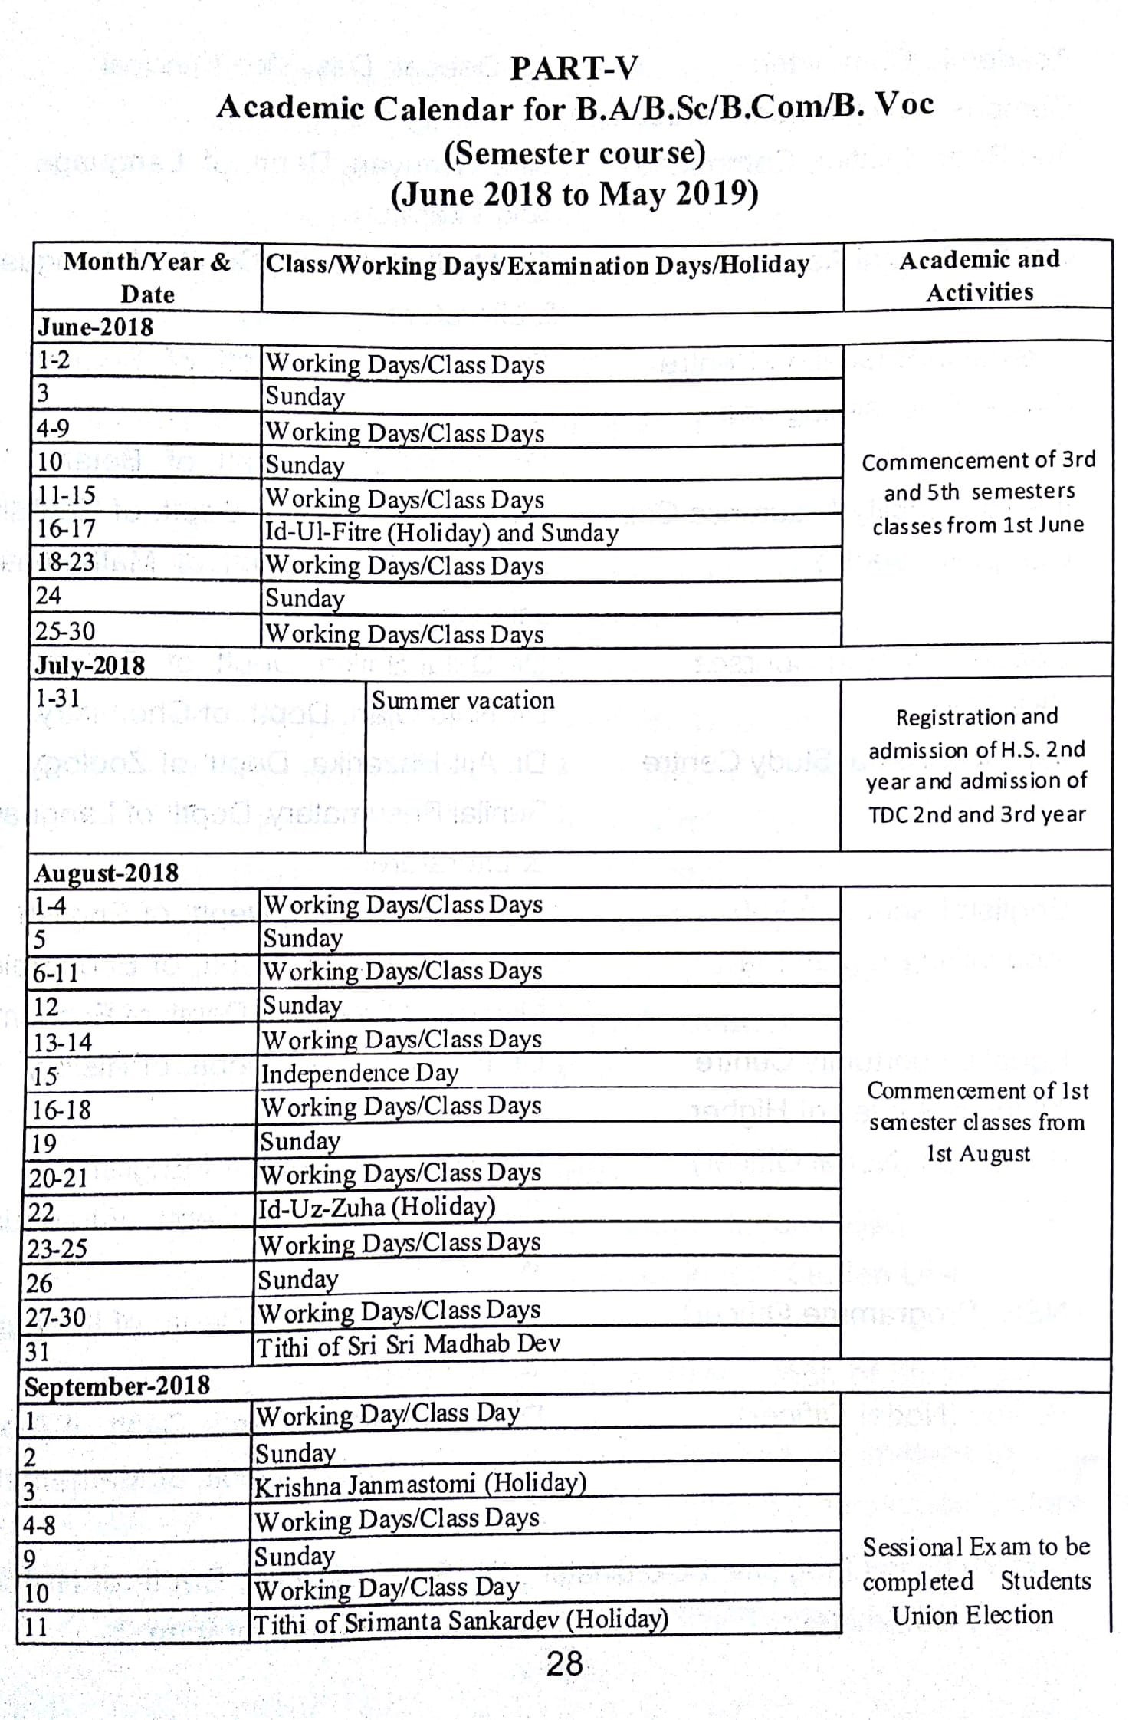
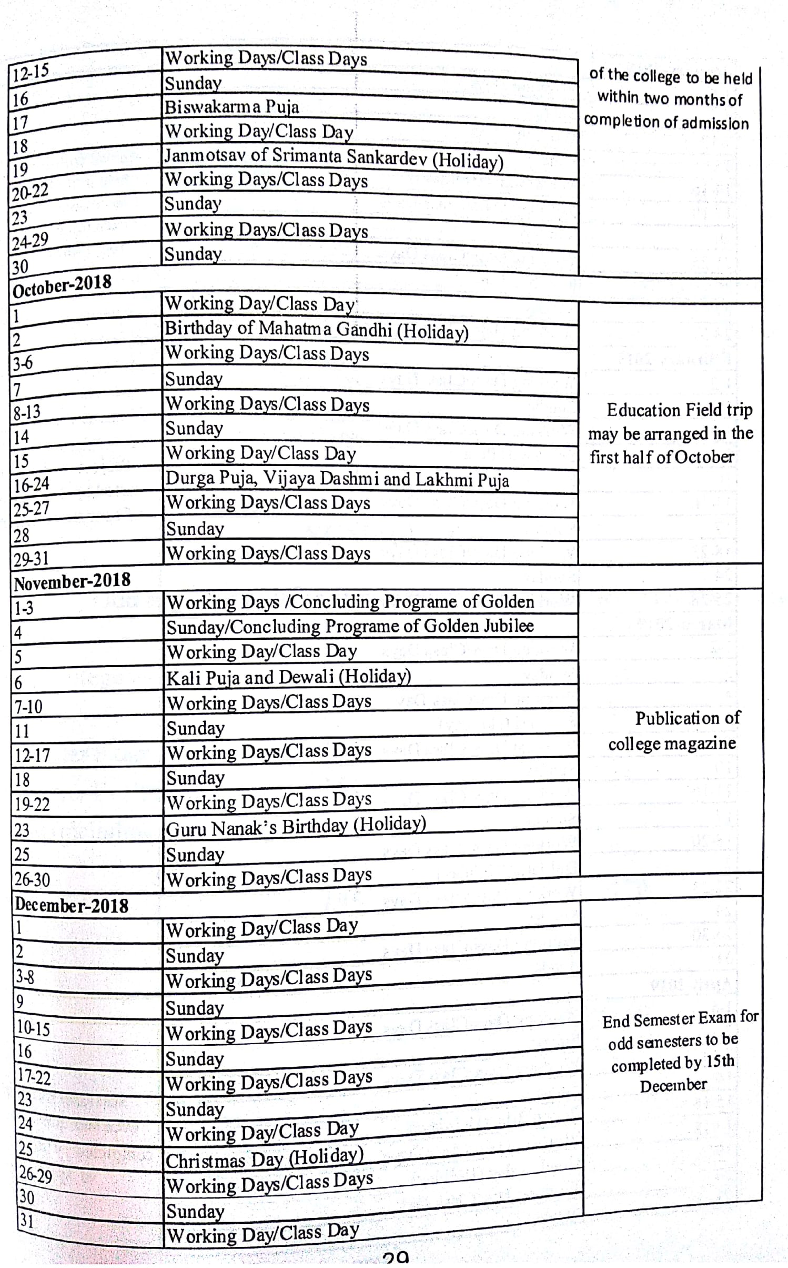
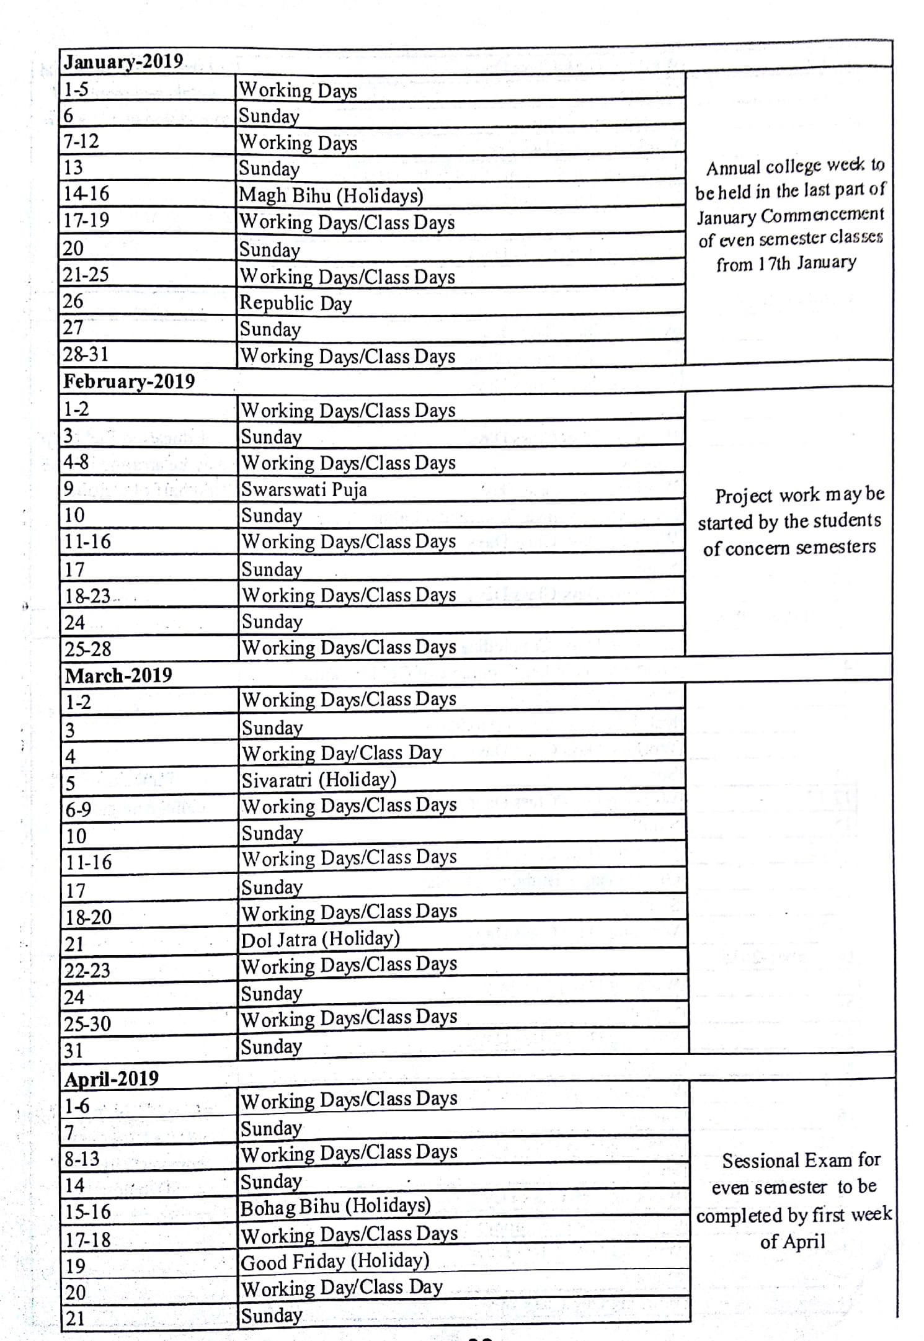

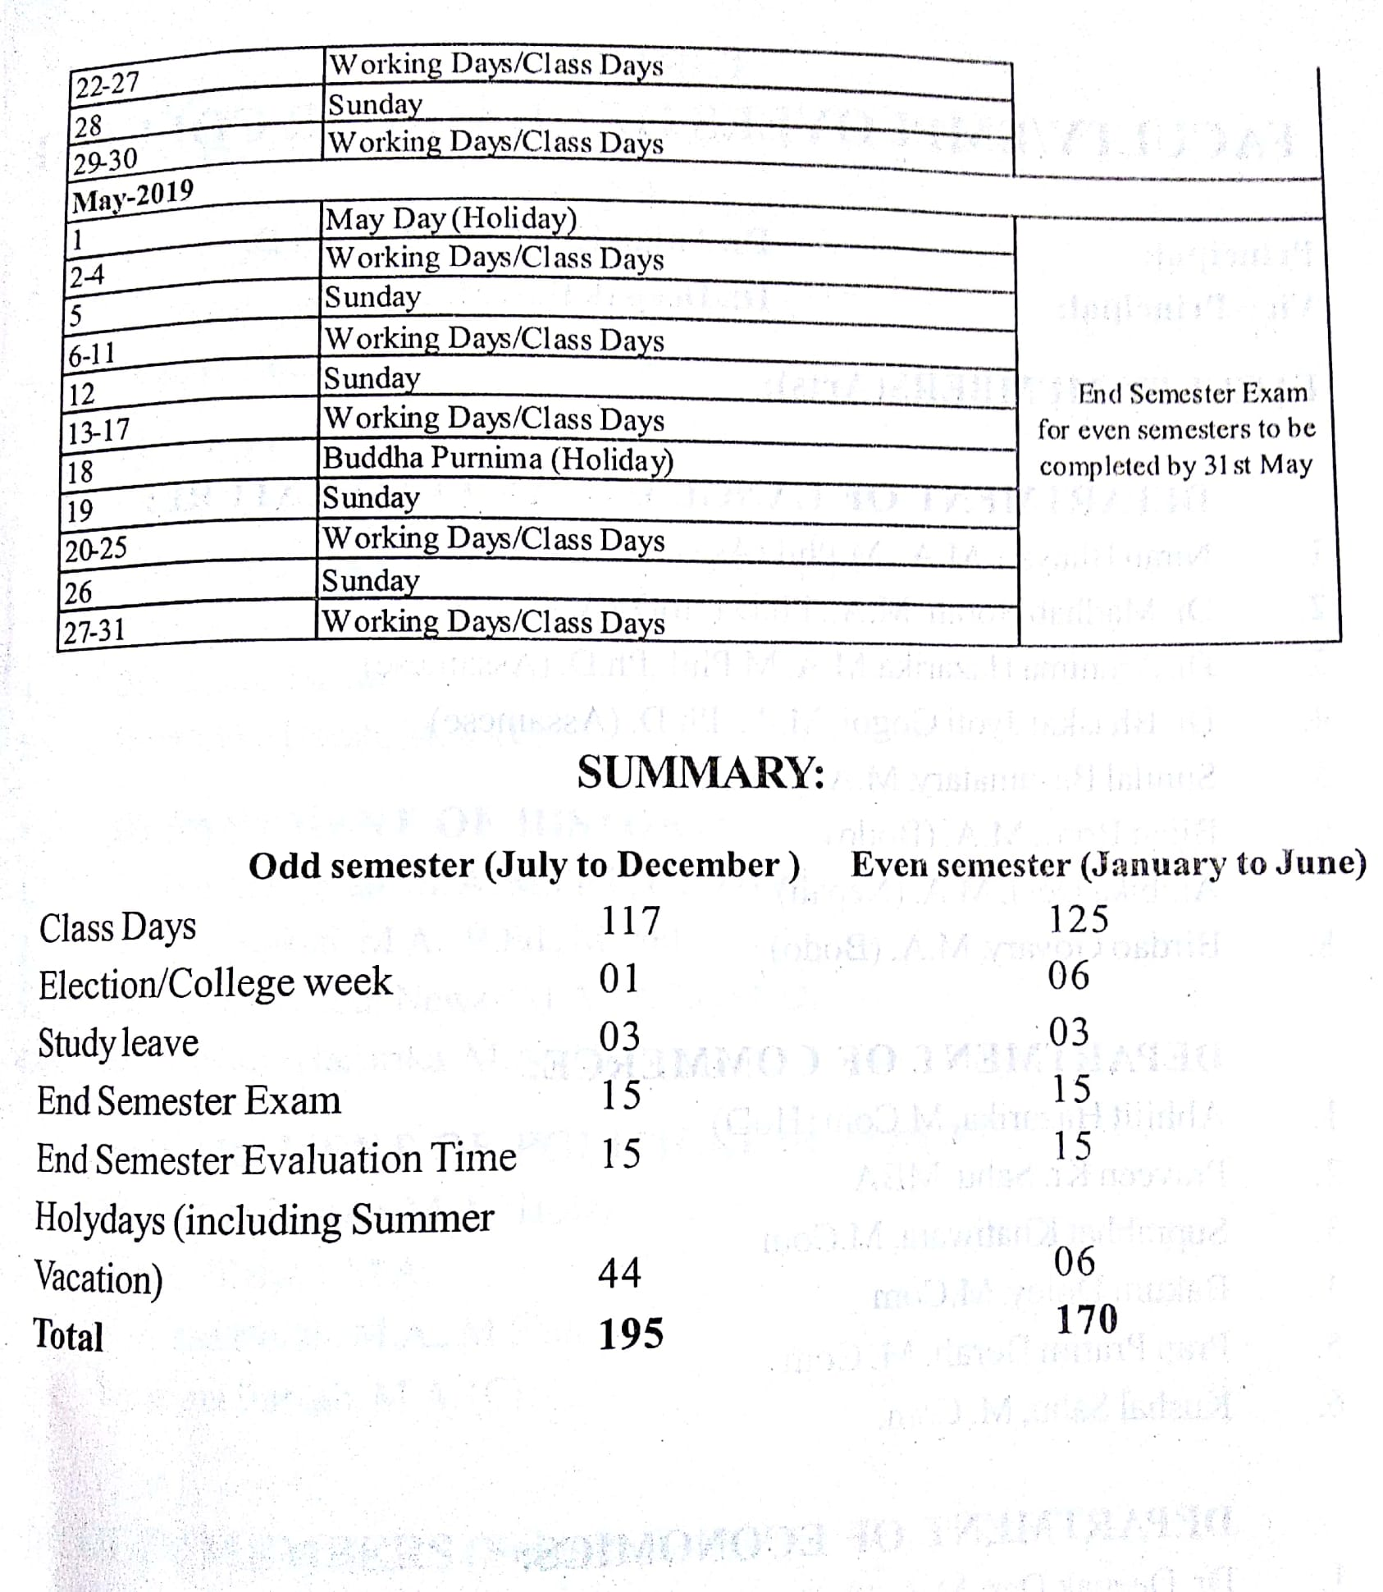

ANNEXURE- III
SWOT ANALYSIS
The college constitutes a major space meant for higher learning in the Gohpur Sub-Division, catering to the need and aspiration of the student community. Rural as the socio economic background and is, the institution wages relentless effort at realizing all-round development of the budding aspirants. Affiliated to the Gauhati University, the college provides education in multiple disciplines, and has carved a niche for itself in the educational map of the region. As the institution has its strengths, it is not away from weakness. With the noble vision, it makes advancement on the basis of strengths, but addressing the weakness within an effective and constructive framework.
Strengths: Since its inception in 1967, this pioneer Institution of higher education has slowly, but firmly gathered intellectual momentum under the dynamic leadership of different stakeholders of education in the college and of the region. It has now emerged as real hub of academic importance accommodating to the regional needs. The region is a place of conglomeration of people of diverse creeds and communities involving the Bodos, Misings, Tea-garden Communities, Assamese, Bengalis, Nepalese, and others. With such a cosmopolitan backdrop, the college has tried its best to deliver quality education to the student community. In recent years, there has been a constant effort to improvise infrastructure, course designs and teaching-learning conditions. As a result of this, the college has been able to access funds from different agencies such as the Department of Science and Technology, Department of Bio Technology, UGC, ICHR etc. Moreover, there has been a consistent rise in research oriented activities in the college. The prominent areas of the strengths of the college are:
- Strongly motivated teaching community, that has demonstrated unprecedented zeal, enthusiasm and efficiency towards the teaching-learning enterprise by incorporating new and effective means of classroom teaching as well as by keeping themselves updated with regard to their domain of knowledge, and engaging themselves in research activities. Justifying this, the college possesses a large numbers faculties having Ph.D.
- A great number of minor and major research projects have been allotted to the teacher community of this institution.
- A Biotech Hub has been established in the college funded by the Department of Bio-Technology, Govt. of India.
- A good number of new generation courses like Medical Laboratory Technician, Mass Media, Health Care and Nursing, Theatre Stage Craft and Acting, Diploma in Entrepreneurship etc., have been introduced, and are running successfully.
- The college also runs parallel courses under open universities namely K.K. Handiqui State Open University, IGNOU and Institute of Distance and Open Learning, Gauhati University. A large number of students enroll in both Under Graduate and Post Graduate level courses in different streams of Arts, Science and Commerce through the study centres of these open universities.
- The library of the college is well-equipped with a rich and constantly growing collection of books and journals. The digitization of the library has been accomplished in due course of time. The library users are increasing every year, and the library has proved to be a hub of resources for faculty members, researchers and students. Besides the central library, each department is equipped with their own departmental libraries.
- There has been a continuous effort at converting traditional lecture halls to smart class room. Virtual class room and digital classrooms are built and more will be added in the near future
- In addition to the laboratories in the department of Physics, Chemistry, Botany, MLT, Zoology and Education (in the arts faculty), the English Department has a well equipped Language Laboratory that imparts skill in Spoken English.
- A state of the art gymnasium cum indoor stadium has been built, and the sporting culture in the college has acquired a dynamic state
- The college has girls’ hostel which can accommodate 92 girls hailing from fur flung areas.
- A large number of students enroll in NCC and successfully complete the training. The scheme has helped a lot of students in finding jobs in defence and other allied services.
- The college frequently hosts different national level seminars and workshops of academic and cultural importance.
- The student and teacher community of the college, showcasing their concerted effort, demonstrate vibrant urge to undertake different extension activities and campaigns like cleanliness drive, holding health camps etc. for the betterment of socio-cultural health and hygiene in the society.
- The college has to its credit different scholarship and merit award schemes, which are annually offered to many poor, but meritorious students.
- A few of the students have demonstrated their interest and skills in games and sports, and they have made the college proud by participating and winning silver medal in international events. Frequently, volley ball and football, badminton coaching are instituted, and competitions are held that provide good training for budding players.
- The college has an approximately 5 Hectares land resource which is used for paddy cultivation.
- Not the least, the college has produced a lot of prominent persons who have demonstrated their leadership roles in academic, administrative and social arena. Frequent co-operation with such alumni provide glamour and glory to the great tradition of the college. These are the few of the prominent points of relative strengths that the college has availed during its journey in the quest for excellence in knowledge.
Weaknesses: There are weaknesses too which, of course, can be ameliorated by the concerted effort of different stakeholders of education within and outside the college, the govt. and funding agencies of the major weaknesses mention can be made of
- Limitation in the introduction of newer Curriculum and syllabus due to lack of academic freedom arising from being affiliated to a university.
- Consultancy and Industrial linage lacking due to absence of industries and companies in the region.
- Desperately poor teacher student ratio particularly in Arts stream is another problem faced by the College. A teacher has to teach more than 400 students in a few of the classes. This is terribly poor situation.
- The dominance of traditional liberal Arts subjects motivates lesser number of students. As most of the students come from the poor Socio-economic background,they are in need of getting early employment; in this case, subjects of traditional interest motivate only a limited number of students to excel in their learning.
- As the college is surrounded by small streams coming down from the adjacent Hills of Arunachal Pradesh, most of the times, it remains inundated and the normal routines of the College are disrupted frequently.
Such weaknesses as mentioned, although restrain the required pace of progress, do not necessarily halt the journey, and we strongly believe that appropriate, well-planned and relevant steps, if taken in time, can put the necessary momentum to the journey of the college.
Opportunities: The past experiences, the surrounding socio-economic and cultural perspectives of the College, the critical elaboration of the changes taking place in the society and the nation at large and rapidly transforming socio-cultural, moral and ethical outlook of the student, teacher and the community help us realize the hindsight in identifying the opportunities that the college may access to. These can be as such:
- Industry oriented courses can be designed to ensure employability.
- Ample scope for providing consultancy services.
- The great pool of sport talent seems to be abundant among the SC and ST Communities like the Bodo, Mising and Tea garden tribes. Proper training, workshops and instituting competitions can certainly boost their talents to grow.
- By applying appropriate technology, the land resources can be exploited for generation of income.
- The new generation of courses like M.L.T., Mass Media, diploma in Entrepreneurship etc have the potential of opening new opportunities for self-employment and enterprise. Such courses have the tremendous potential to change the socio-economic face of the society.
- Further introduction of self-financing courses can attract a few number of students who can bring material changes in their post academic career and thus help the College to be a path finder.
- Encouraging the optional use of man and material resources of the College can be a harbinger for the quest of quality education. The teaching and administrative staff of the College with their dynamic leadership roles can exploit the available resources at their best and thus can transform the ‘alma mater’ to a real ground of formation of human capital.
- The Biotech Hub, the Science Laboratories, the MLT lab and Language Labs are assets that can make a real difference in educational sector.
- As an old institution for higher education in the region, it can give itself a competitive edge for assuaging the intellectual and academic need of the student community.
- Optimum use of infrastructure.
Threats: The threats are the concomitant elements of every system and institution. These are meant for being effectively dealt with. These are as under:
- Making provision for more student intake as the number continues to rise. For this, more teachers, infrastructure and other support systems need to be increased.
- The teacher-student ratio is a real threat that constantly puts pressure on the system.
- Income generation potentialities can be searched out. More and more self-financing and job oriented courses are to be given preference.
Thus, the challenges as mentioned are seen that these are seen as the bottleneck to the smooth run of the institution. What is the most urgent is the visionary outlook and missionary zeal that can help to tread a long way towards achieving the milestones and letting the new bench marks be curved.

